# **Towards exaflops and exabytes**

Computational science use high-performance computer systems to simulate the physical lows and numerical methods

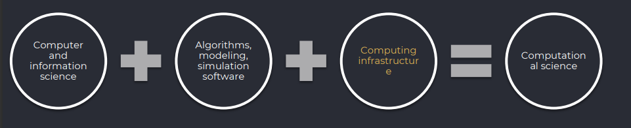

## History Of Computing

ENIAC (Electronic Numerical Integrator and Computer)

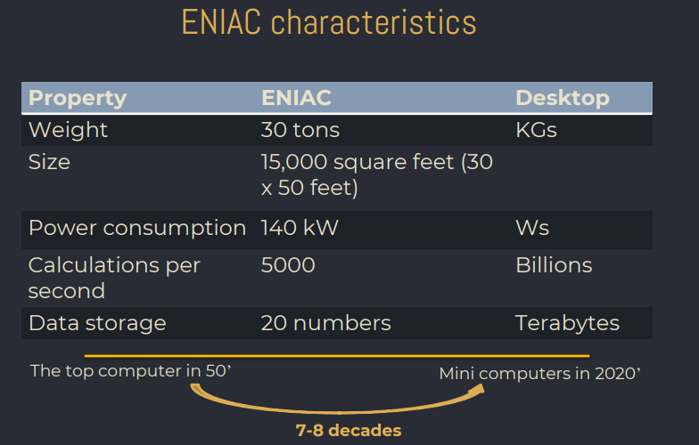

von Neumann architecture

In 1945, mathematician John von Neumann demonstrated that a computer could have a simple and fixed structure, consists of a

• CPU – to perform arithmetic and logical operations,

• Memory – to store data and instructions.

• Bus – to connect the CPU and memory, allowing the CPU to read and write data to memory.

This architecture is used in most modern computers and is considered the standard design for computers.

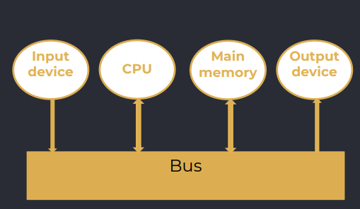

Purely sequential architecture

• Read instruction from memory

• Read operands

• Compute Processing

• Write result

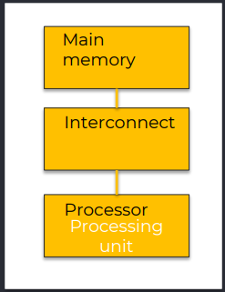

## PERFORMANCE METRICS

*FLOPS (Floating Point Operations Per Second)*

FLOPS indicates the number of floating point operations (additions, subtractions, multiplications, or divisions) a computer can perform in one second.

The higher the FLOPS rating, the faster the computer can perform calculations and process data.

For example, if a computer has a FLOPS rating of 1 teraflop (1 trillion FLOPS), it means that it can perform 1 trillion floating-point operations per second.

• ENIAC could process ~ 500 flops in 1946,

• Simple computer – a few hundred Gflops

• First supercomputer in 1993 (Los Alamos National Lab, 1024 cores) is less power than my notebook

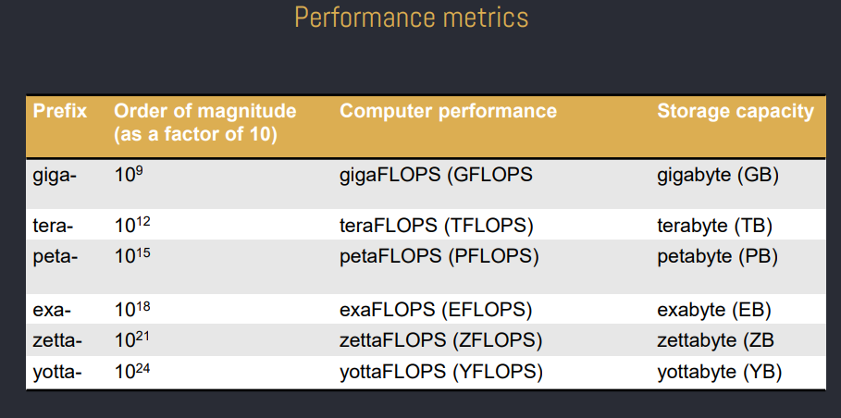

• Rmax - maximum sustained performance achieved by a supercomputer during real-world applications and is also measured in FLOPS.

• Rpeak - theoretical peak performance of the supercomputer based on its hardware specifications.

• Performance Efficiency - compares a supercomputer's actual performance (Rmax) to its peak theoretical performance (Rpeak).

Rpeak = (N. of proc. elements) x (Peak performance per proc. element)

For example, if you have 1000 CPUs, and each CPU has a peak performance of 1 Tflops, the Rpeak would be: Rpeak = 1000 CPUs x 1 teraflop/CPU = 1000 teraflops = 1 petaflop

Additional performance metrics

• Power Efficiency - measures how much computational work a supercomputer can perform per watt of power consumed.

• Memory Bandwidth - how quickly data can be accessed from the computer's memory.

• Interconnect performance - the communication network between the individual processing nodes in a supercomputer.

• Scalability - how well a supercomputer can handle an increasing number of processing nodes while maintaining high performance.

## INTRODUCTION TO EXAFLOP COMPUTING?

*How big is exaflop?*

An exaflop is representing one quintillion (10^18) floating-point operations (billion of billions) per second (FLOPS).

• to perform over a billion calculations per second for every person

• computing power of about 50 million laptops combined

• approximately 250 million DVDs, which would weigh over 3,000 metric tons

*Top500*

• The term "Top500" - ranking of the 500 most powerful computer systems in the world.

• The list is updated twice a year and is published by a group of experts from the United States and Germany.

• The rankings are based on the performance of these supercomputers in running the LINPACK benchmark, which tests their ability to solve a dense system of linear equations. The performance is measured in FLOPS (floating-point operations per second).

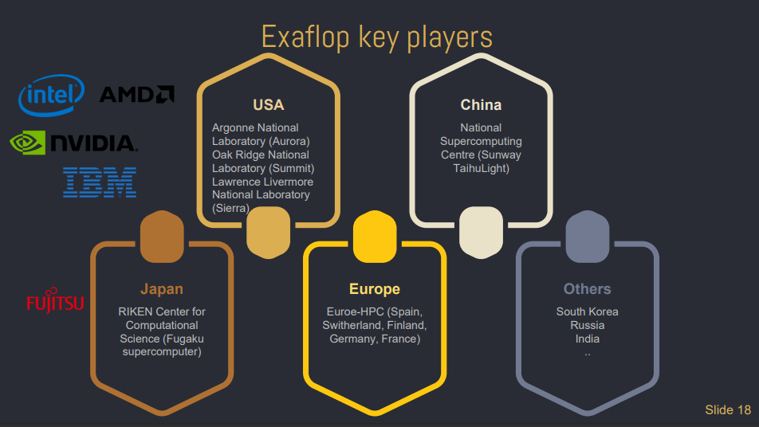

*Towards exaflops – Top500*

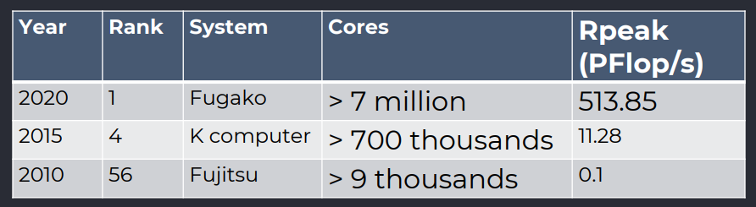

*Green’500*

• Performance per Watt - MFLOPS/W.

• In 2007, several hundred MFLOPS/W, while the latest entries have surpassed tens of thousands of MFLOPS/W.

• Exascale computing has driven a greater focus on energy efficiency, as Exascale systems are highly power-hungry. Many Exascale projects and supercomputers are designed with a strong emphasis on energy-efficient architectures.

*HPCG’500 (High Performance Conjugate Gradients)*

• Sparse matrix-vector multiplication.

• Vector updates.

• Global dot products.

• Local symmetric Gauss-Seidel smoother.

• Sparse triangular solve (as part of the Gauss-Seidel smoother).

• Driven by multigrid preconditioned conjugate gradient algorithm that exercises the key kernels on a nested set of coarse grids.

• Reference implementation is written in C++ with MPI and OpenMP support

## EXASCALE APPLICATIONS

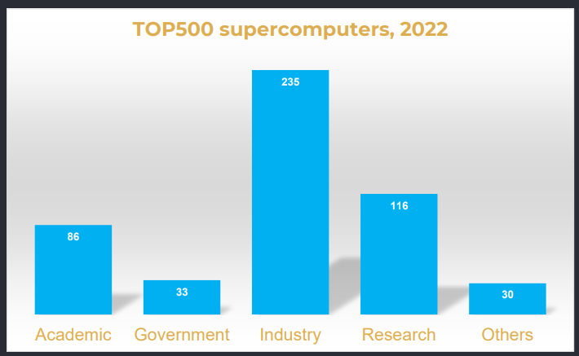

Thrusts in HPC – different scales and dimensions

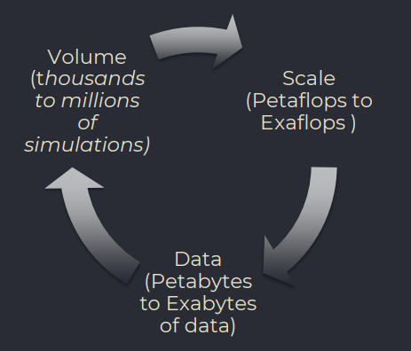

*Towards exabytes*

• Artificial intelligence and machine learning

• Internet-connected devices and IoT (predictions is more than 75 billion IoT devices in use by 2025)

• Growth of big data and analytics

• Video and other multimedia content

Large Synoptic Survey Telescope (2019)

• 15 TB per nigh for 10 years

• 100 PB image archive

• 20 PB final database catalog

Square Kilometer Array (2024)

• Up to 1 EB per day (about internet traffic today)

• 100 Pflops/s processing power

1 EB = 1018 bytes

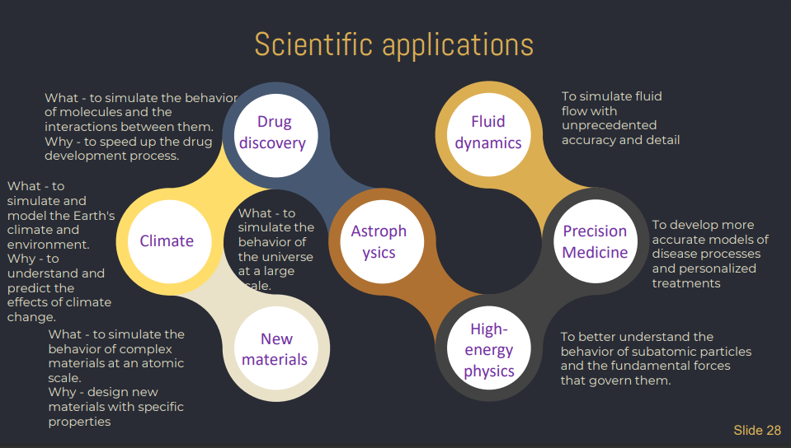

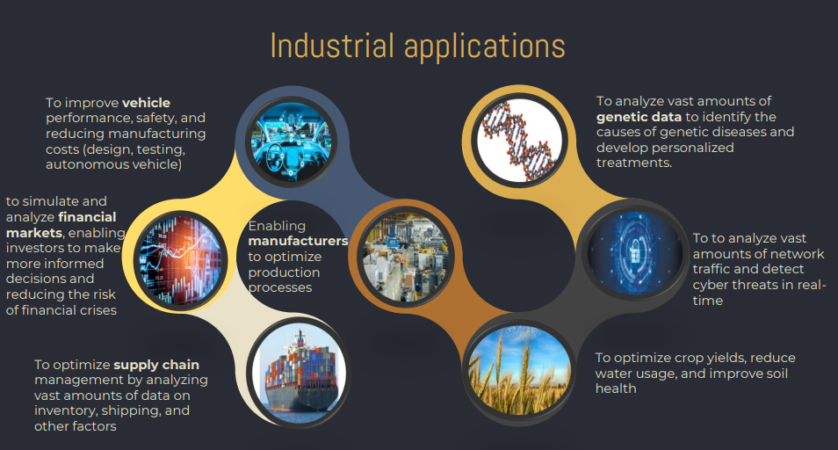

*Industrial applications – use cases*

***FedEx*** simulate and plan the delivery of millions of items around the world each day through its fleet of 600+ aircraft and 75,000 vehicles

The ***NASDAQ*** Stock Exchange process over two billion transactions daily at rates of more than 200,000 transactions per second.

***WalMart*** typically stocks 500,000 products each, and suppliers compete fiercely for shelf space. WalMart uses the resources for shelf space determinations, store planning and resource planning.

## INSIDE THE DATA CENTERS & ARCHITECTURES

*Biggest Data Centers*

Range International Information Group Data Center in Langfang, China

• Area: around 6.3 million square feet (approximately 110 football fields)

• Total IT capacity: over 1.2 million servers

*Data Centers Cooling Systems*

• Air Cooling: air conditioning units and fans to circulate cool air.

• Liquid Cooling: Utilizes liquid coolant to directly absorb heat from computing components. Can be direct-to-chip or immersion cooling.

• Chilled Water Cooling: Circulates chilled water through cooling pipes or coils.

*Specific Servers*

The leading companies build specific servers to meet their unique requirements and optimize their data center operations

• ***Atos*** (more 100K employees), as a global IT services offers a range of customized servers designed for various industries and applications.

• ***Google*** has its own custom-built servers, known as Google Servers, designed to handle the massive scale and unique workloads of its search and other services.

• ***Facebook*** has developed its specialized servers, such as the Open Compute Project servers.

*COMPUTATIONAL NODES*

• CPU nodes: multiple CPU/Cores from vendors like Intel or AMD.

• GPU nodes: in addition to CPUs to accelerate computation.

• Accelerator nodes: specialized accelerators such as FPGAs.

• Co-processor nodes: additional hardware such as Intel Xeon Phi

NVidia Tesla V 100

• Peak performance - around 15000 GFLOPS

• Number of cores - 5120

*RACKS*

• Supercomputer can encompass entire room

• 490/500 top supercomputers are rack based systems

• Racks are black metal cabinets that enclose the infrastructure

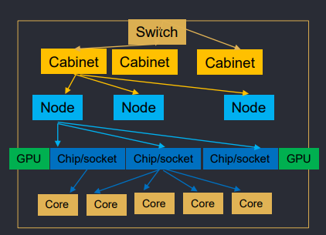

*RACKS AND COOLING*

• Behind is the cooling system that moves the hot airs through heat exchanges

In racks we have

• storages

• network switches

• compute nodes

*Computational nodes - SMP*

• All processors share the same physical main memory

• Memory bandwidth per processor is limiting factor for this type of architecture

• Memory access time is approximately the same for each processor

• All processors access all memory as a single global address space.

• Typical size: 2-20 processors

• AMD - EPYC 7763 has 64 cores

• Intel Xeon W-3175X has 28 cores

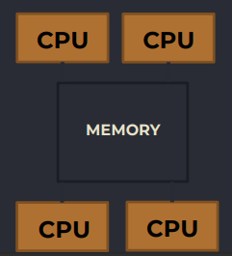

• ***Performance***: Only if some work can be done in parallel

• ***Availability***: Failure of a single processor does not halt the system

• ***Incremental growth***: Increase performance by adding additional processors

• ***Scaling***: Different computers can have different number of processors

*Computational nodes - NUMA*

All processors share the same physical main memory

• Some memory is closer to a certain processor than other memory

• The whole memory is still addressable from all processors

• Depending on what data it process or retrieves, the access time might vary strongly.

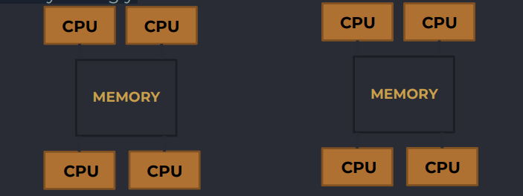

• Implements the shared memory model in distributed systems, which have no physical shared memory.

• The shared memory model provides a virtual address space shared between all nodes.

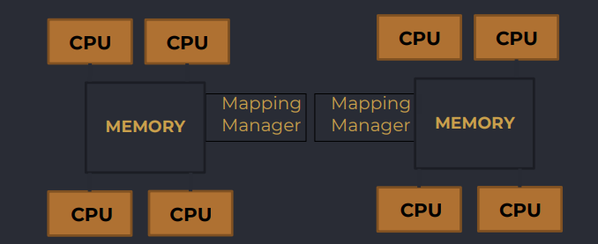

• Reduces the memory bottleneck compared to SMPs

• More difficult to program efficiently

• To reduce effects of nonuniform memory access, caches are often used

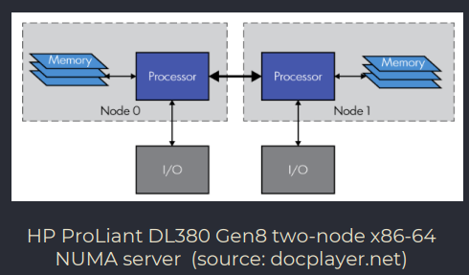

*INTERCONNECT*

The interconnects allow for highspeed communication between computational nodes. These interconnects are designed to minimize latency and maximize bandwidth:

• Infiniband (232/500)

• Omni-Path by Intel (38)

• Gigabit Ethernet

Infiniband features

• Bandwidth: 200GB/s (Gigabit 1)

• Latency: 1 microsecond (Gigabit 10)

• Message rate: 200 million messages per second (1 million)

## EXASCLAE PROGRAMMING

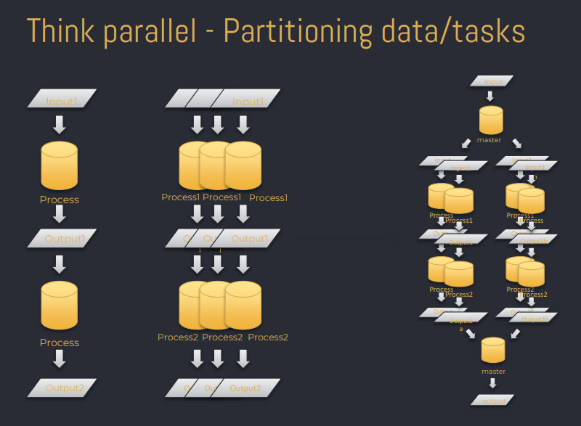

*What is a distributed computing environment?*

• A distributed system is a network of autonomous computers.

• The computers do not share physical memory or processors. They communicate with each other using messages.

• Distributed computing is computing performed in a distributed system.

Distributed memory architecture

• Each processor has its own memory.

• Is scalable, no overhead for cache coherency.

• Programmer is responsible for many details of communication between processors.

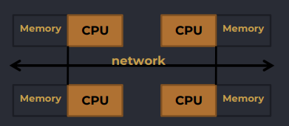

Message Passing Interface (MPI) - programming model for distributed-memory parallel computing. OpenMP - shared-memory parallel computing. It allows multiple threads to execute in parallel within a single node, improving performance for multi-core processors.

CUDA - programming model developed by NVIDIA for GPUs.

## PREDICTIONS AND LAWS

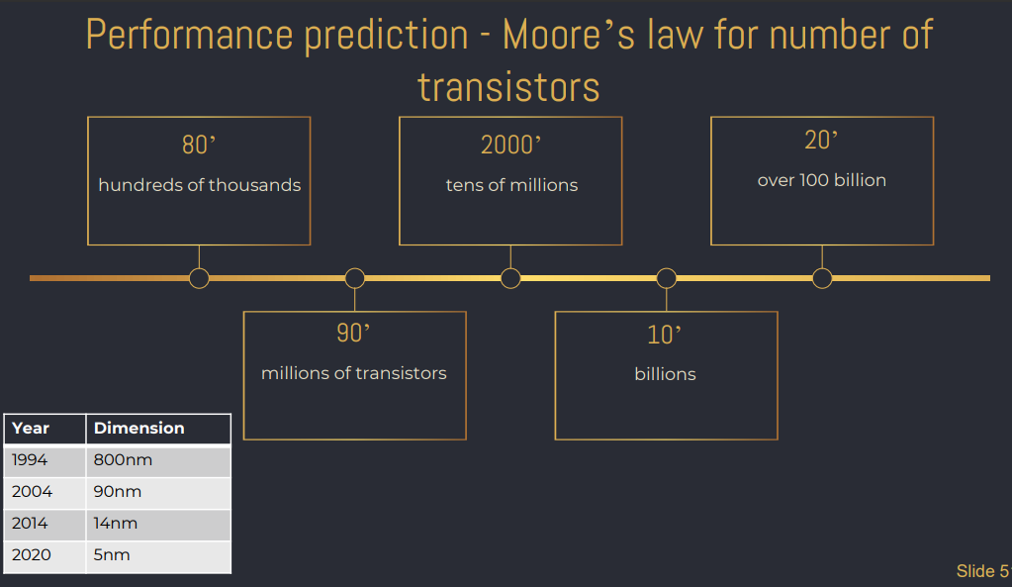

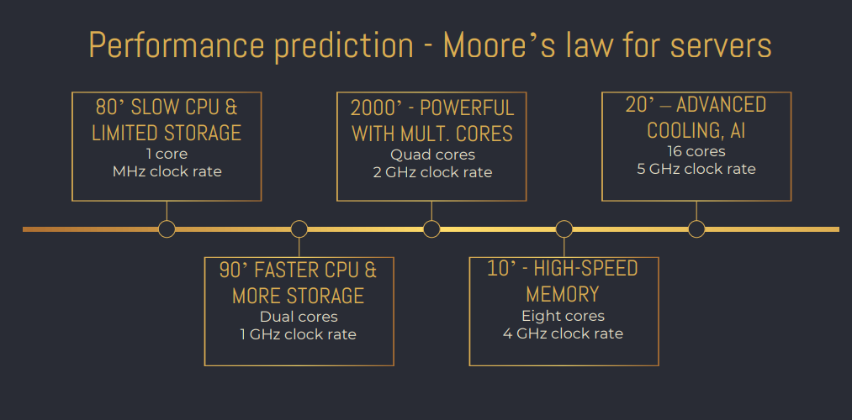

*Cost of building a new chip fabrication - Rock’s law*

Arthur Rock, Intel financier “The cost of capital equipment to build semiconductors will double every four years”. The chip plant costs

• 1968 – 12K USD

• 2010 – 4 billion USD

• 2020 – 10-15 Billions

Semiconductor leaders: Samsung, Intel, SK Hynix, Qualcomm, Micron, Broadcom, AMD, Texas Instruments Semiconductor producers: Taiwan, South Korea, Japan, China and USA (85%)

Computational energy - Koomey’s law

Jonathan Koomey, 2007, consulting professor at Stanford.

The computational energy efficiency (operations per joule) doubles approximately every 1.2 years

The law is also related to the trend of "green computing" where the industry is trying to reduce the environmental footprint of their products by reducing the energy consumption.

## CHALLANGES

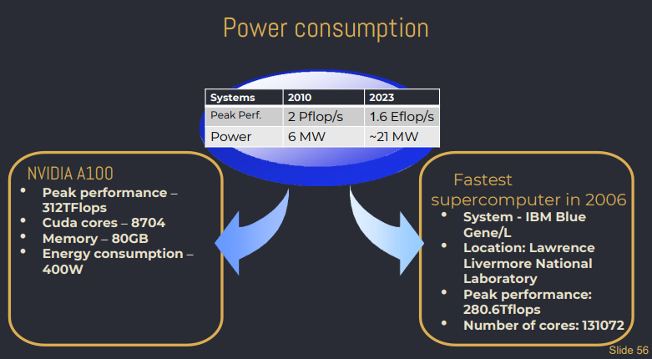

*Communication and Interconnects*

• High-speed communication is critical for efficient data exchange between components.

• Efficient interconnect technologies and communication protocols are needed to ensure that data can be shared quickly and efficiently between nodes to minimize communication bottlenecks.

*Power Consumption*

• Exascale systems are incredibly power-hungry, reaching up to hundreds of megawatts.

• Cooling and energy efficiency become critical concerns.

• Novel power management techniques and energy-aware designs are necessary to keep operational costs manageable.

*Memory and Storage*

• Handling massive datasets and achieving high bandwidth for data movement is a challenge. It is needed to use innovative storage technologies and data management strategies

• Memory hierarchies and storage systems must be optimized for performance and energy efficiency.

*Fault Tolerance*

• With millions of components, hardware failures become more frequent.

• Reliable and scalable fault tolerance mechanisms are crucial.

• Checkpoint/restart protocols, redundant computing, and fault prediction algorithms must be developed to maintain system stability

*Scalability and Parallelism*

• Scaling applications to millions of cores is complex and requires rethinking software design.

• Load balancing, data distribution, and synchronization overheads need careful management.

• Advanced parallel programming models and tools are vital for efficient utilization of Exascale resources.

*Data Privacy and Security:*

• Strong encryption, data access controls, and secure data handling protocols are essential to safeguard data in Exascale environments.

## FUTURE TRENDS

*In-memory computing*

• In-memory computing is a computing paradigm where data is processed directly within the computer's memory (RAM), as opposed to traditional computing systems where data is read from memory, processed by the CPU, and then written back to memory or storage.

• This approach keeps large amounts of data in memory, enabling faster and more efficient data processing. In-memory computing has gained significant attention in recent years due to the increasing need for high-performance computing (HPC) and the growing demand for processing large datasets.

Example to sum of the following elements: [1, 2, 3, 4, 5, 6]

In a traditional computing scenario, the data would be stored in memory (RAM) initially, but the CPU would need to read each number from memory one by one, perform the addition, and then write the result back to memory. This process involves multiple data movements between the CPU and memory for each addition operation, which can introduce latency and slow down the computation.

*Convergence AI with HPC*

• The convergence of AI and HPC represents a transformative trend in the field of computational science and technology.

• AI and HPC, once considered separate disciplines, are now coming together to leverage each other's strengths, leading to AI-driven simulations and enhanced problem-solving capabilities

*Neuromorphic Computing*

• The human brain is a marvel of efficiency and adaptability, processing vast amounts of data with minimal power consumption.

• Neuromorphic computing seeks to replicate these features by using neuromorphic chips, which consist of specialized circuits designed to emulate the behavior of neurons and synapses.

• Unlike traditional von Neumann architectures, where computation and memory are separate, neuromorphic computing aims to combine computation and memory, mirroring the brain's distributed and parallel processing capabilities.

*Quantum-Inspired Computing*

• Quantum-inspired computing involves the emulation of quantum algorithms using classical hardware.

• While classical computers lack the intrinsic properties of quantum systems, such as superposition and entanglement, they can still simulate certain aspects of quantum algorithms.

• By carefully designing classical algorithms that mimic the behavior of quantum algorithms, researchers can explore quantum computation techniques on classical hardware.

*HPDA*

• In the era of big data and AI/ML, the sheer volume, velocity, and variety of data generated are tremendous.

• Traditional computing models primarily focused on processing power and computation can no longer handle these data-intensive workloads.

• Data-centric computing acknowledges that data is a critical resource, and efficient management is vital for achieving optimal performance.

# **Introduction to Databases**

# **Concepts of Big Data**

*Big Data is everywhere*

* Finance
* Healthcare
* Retail
* Transport

*Big Data enables to*

* Making better business decisions (improve store layout and product placement, optimize pricing and promotions, and personalize marketing messages)
* Understanding your customers (Disnay analyzes visitors behaviour at its theme parks)
* Delivering smarter services or products (to identify unusual patterns or anomalies that could indicate fraud)

Big Data is generated a lot by machines, sensors and other devices.

JUNIPER RESEARCH: The number of connected devices in 2021 is 46 billion.

MARTECH ADVISOR (WORLD'S LEADING MARTECH ADVISOR): By 2030 125 billion devices

UPS: 16 Million shipments per day, 16 PBs of data about its operations

Walmart: 250 Million customers, 10,000 stores, 2.5 petabytes data collected every 60 minutes

## DATA FORMATS AND TYPES

*DATA TYPES*

• Structured- clean, labeled, and organized.

• Semi-structured and unstructured - hasn’t been organized for analysis.

• Multi-structured – a combination of both structured and unstructured.

*STRUCTURED DATA*

• A pre-defined data model that is, therefore, straightforward to analyse.

• A tabular format with a relationship between the different rows and columns.

Examples: Excel files or SQL databases. Each of these has structured rows and columns that can be sorted.

*STRUCTURED DATA - SQL DATABASES*

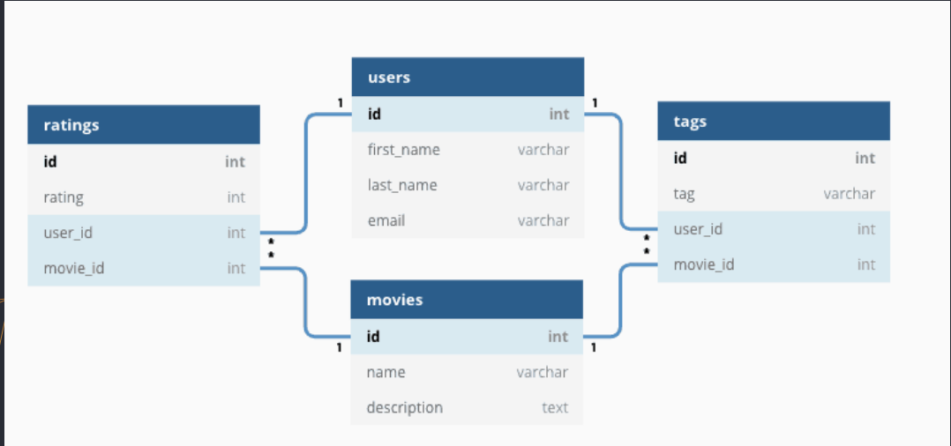

*SQL LUNGUAGE*

***Data Manipulation Language*** - SELECT, INSERT, UPDATE, DELETE

• Example: SELECT * FROM Customer WHERE City = ‘Yerevan';

***Data Definition Language*** – CREATE, ALTER, DROP, RENAME

• Example: CREATE TABLE Product (ID INT PRIMARY KEY, Name VARCHAR(20) NOT NULL, Price DECIMAL NULL);

***Data Control Language*** – GRANT, DENY, REVOKE

• Example: GRANT SELECT, INSERT, UPDATE ON Product TO SQL_user;

*STRUCTURED DATA - SPREADSHEETS*

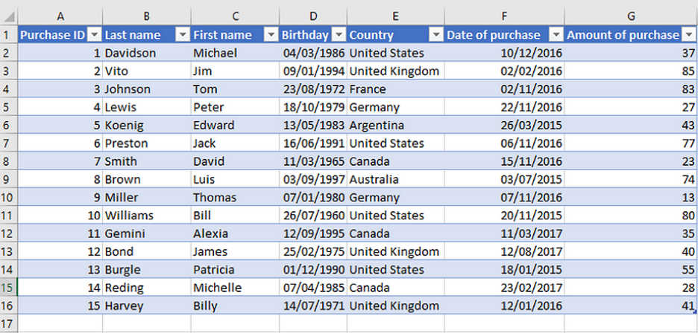

*SEMI-STRUCTURED DATA*

Semi-structured data does not conform to the rigid structure of traditional structured data but has some organizational properties that make it easier to process than unstructured data.

Semi-structured data is typically hierarchical, with elements containing data and metadata, such as tags or attributes.

Examples: JSON and XML, e-mails semi-structured by Sender (automatically categorized into folders, like Inbox, Spam, Promotions, etc), or Tweets organized by hashtags. For example, while most customers may have an e-mail address, some might have multiple ones, and some might have none.

*SEMI-STRUCTURED DATA - XML*

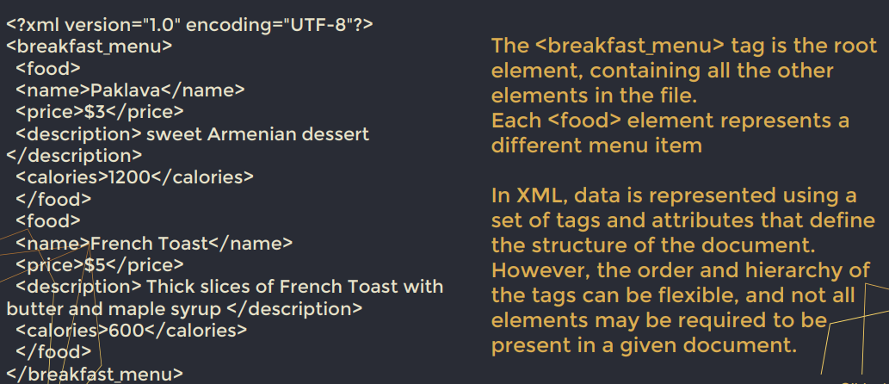

SEMI-STRUCTURED DATA - JSON

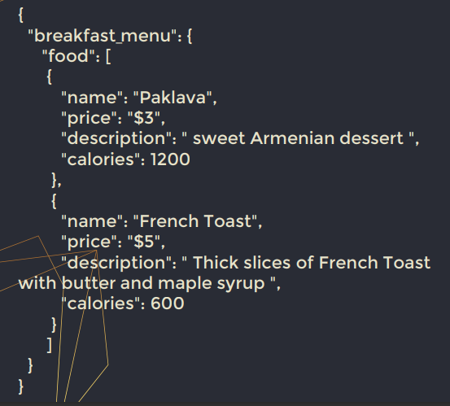

*UNSTRUCTURED DATA*

• Does not have a pre-defined data model or is not organized in a pre-defined manner.

• Unstructured information is typically text-heavy but may contain data such as dates, numbers, and facts.

• This results in irregularities and ambiguities that make it difficult to understand using traditional programs compared to data stored in structured databases.

Examples: images, audio, video files, or No-SQL databases.

# **DATA STORES**

*OPTION 1: FILE STORAGE*

Files can be stored in local file systems on the hard disk of your personal computer and removable media such as USB drives.

In most organizations, important data files are stored centrally in a shared file storage system. Increasingly, that central storage location is hosted in the cloud, enabling cost-effective, secure, and reliable storage for large volumes of data.

Text file delimitation: CSV, TSV, JSON, XML, etc.

Optimized formats: Parquet (developed by Cloudera and Twitter), Optimized Row Columnar format (HortonWorks), Avro (Apache)

*OPTION 2: RELATIONAL DATABASES FOR STRUCTURED DATA*

The relational DBMS is the most popular DBMS type in the market. Database example of the RDBMS system:

• MySQL

• Oracle

• Microsoft SQL Server database

*CLOUD-BASED RELATIONAL DATABASES*

A cloud database is a scalable content database running on a cloud computing platform.

• Amazon Relational Database Service – Amazon Aurora is compatible with MySQL, PostgreSQL, MariaDB, etc.

• Oracle Cloud Infrastructure Database Service

• Microsoft Azure SQL database

• Google Cloud SQL

• IBM DB2

• MongoDB Atlas

• OpenStack

*OPTION3: NON-RELATIONAL DATABASES FOR UNSTRUCTURED DATA*

NoSQL database is a non-relational Data Management system that does not require a fixed schema. It avoids joins and is easy to scale.

The primary purpose is for distributed data stores with humongous data storage needs.

• Key-value pair

• Column-oriented graph

• Graphs based

• Document-oriented

*DATA WAREHOUSE*

A database is a software system, while a Data Warehousing (DW) is a large centralized repository designed to support analytics and reporting optimized for query and analysis performance.

The DW is the core of the BI system, built for data analysis and reporting.

Example: dropped students?

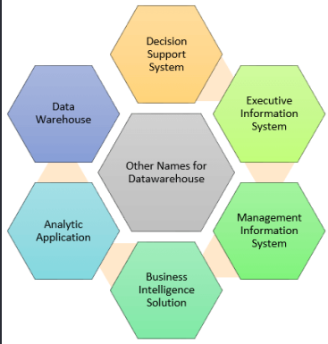

*HOW IT WORKS?*

DW is a central repository of information from one or more data sources.

The data is processed, transformed, and ingested so that users can access the processed data in the DW through BI tools, SQL clients, and spreadsheets.

DW merges information coming from different sources into one comprehensive database.

*ARCHITECTURE*

The DW is based on an RDBMS server, a central information repository surrounded by key DW components to make the entire environment functional, manageable and accessible.

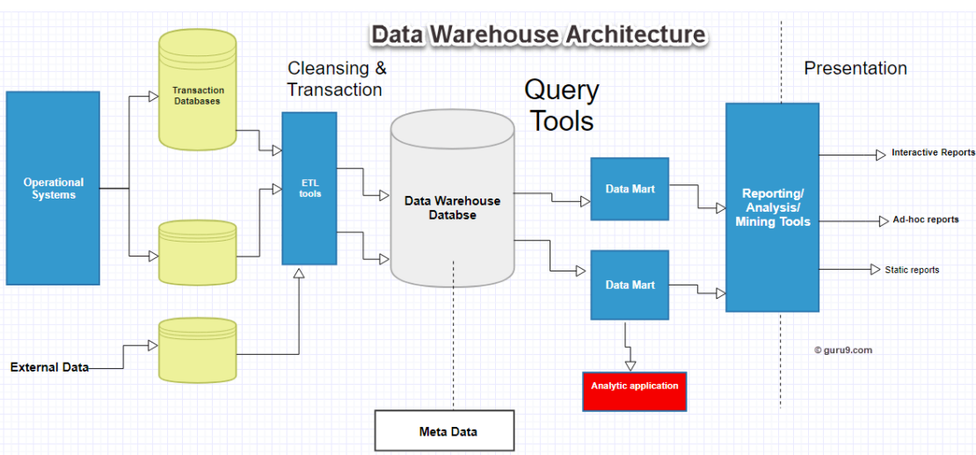

*DATA LAKE*

Data files may be stored in a central data lake (DL) for analysis.

A DL is a storage repository that stores every data type in its native format with no fixed limits on account size or file.

DLs are common in large-scale data analytical processing scenarios, where a large volume of file-based data must be collected and analyzed.

DL has a flat architecture, unlike a hierarchal DW, where data is stored in files and folders. Every data element is given a unique identifier and tagged with metadata information.

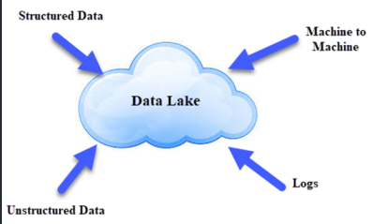

DL is like a large container similar to natural lakes and rivers. Just like in a lake, we have multiple tributaries coming in.

*BENEFITS*

• Scalability: handles large volumes of data from various sources.

• Flexibility: stores unstructured, semi-structured, and structured data in their native format.

• Cost-effective: uses low-cost commodity hardware and open-source software.

• Agility: rapid data exploration and experimentation.

• Integration: integrates with various data processing tools and technologies.

• Security: can implement robust security measures to protect sensitive data.

*DISADVANTAGES*

• Data quality: it stores unstructured and semi-structured data in its native format.

• Complexity: complex to set up and manage.

• Query performance: As data is in its raw form, query performance can be slower than traditional DW solutions, requiring additional processing to optimize query performance.

*DATA PROFESSIONALS*

*DATA ENGINEER*

Responsible for designing, building, and maintaining the infrastructure that supports the storage, processing, and analysis of large volumes of data.

Participates in transforming raw data into a usable format for data scientists, analysts, and other stakeholders to extract insights and make informed decisions.

Tech skills: Data and web service integration, knowledge of databases, data warehouses, Hadoop and Spark to understand relational databases and non-relational data stores.

*DATABASE ADMINISTRATOR*

Manage database systems according to the service-level agreements on availability, performance and cost, which includes security and backup.

Tech skills: SQL, database performance tuning, scripting, system and network design

*DATA ANALYST*

Extracts data from business systems, analyzes it and creates reports and dashboards to highlight trends and other business information for users to generate insights.

A data analyst collects, processes and performs statistical analyses on large datasets. They discover how data can be used to answer questions and solve problems.

Tech skills: Analytics, reporting, data visualization, using statistical tools to create charts and dashboards.

*DATA SCIENTIST*

Gathers and analyzes data from databases and other source systems, running ML algorithms and predictive models; creates data visualizations for business users.

Data scientists are big data wranglers, gathering and analyzing large sets of structured and unstructured data. A data scientist’s role combines computer science, statistics, and mathematics.

Tech skills: Statistics, Python, R, machine learning, SQL, data cleaning, data visualization.

*BUSINESS ANALYST (BI)*

Documents business needs on data analysis and reporting and develops BI systems, reports and dashboards to support them; also works to integrate data in BI systems.

Responsible for researching and analyzing company data to support statistical analysis by the business.

Tech skills: SQL, dimensional modeling, ETL, and data visualization to drive decisions that benefit and grow their business.

# **Big Data INTRODUCTION**

Data Analytics

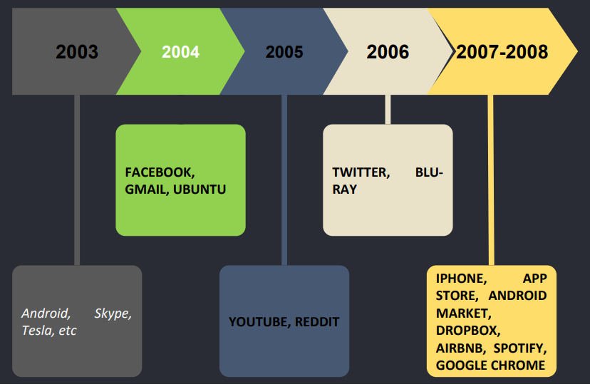

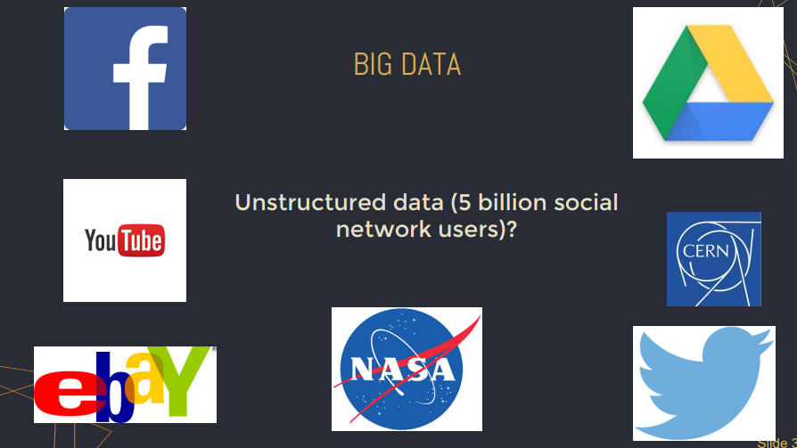

*BIG DATA*

BD is a collection of massive and complex data sets and data volume growing exponentially with a time

● Volume - amount of the data

● Velocity – the speed at which data is being generated

● Variety - different sources and formats

Ernst and Young: BD refers to the dynamic, large, and disparate volumes of data being created by people, tools, and machines.

*BIG DATA:* ***VOLUME*** *(EXABYTES, ZETABYTES)*

BD is about the volume that can reach unprecedented heights.

The data size plays a crucial role in determining the data value.

● Social networks: Facebook 2 billion, YouTube 1 billion, and Instagram 700 million users. These users contribute billions of images, posts, videos, or tweets daily.

● Vehicle: a single connected car can generate 25 GB of data per hour

● Amazon's website: >600 transactions per second.

*BIG DATA:* ***VELOCITY*** *(BATCH, STREAMING)*

BD velocity deals with the speed at which data flows from sources like business processes, application logs, networks, social media sites, sensors, mobile devices, etc.

The flow of data is massive and continuous.

● New York Stock Exchange - approximately 12,000 trades per second

● National Oceanic and Atmospheric Administration (NOAA) - 20 terabytes of weather data per day

● Netflix - streams over 2.4 million hours of content per second

*BIG DATA:* ***VARIETY*** *(STRUCTURED, UNSTRUCTURED)*

Variety refers to heterogeneous sources and the nature of data, both structured and unstructured. BD is only sometimes structured and easy to put into a relational database.

● IoT - including sensor data, GPS data, and telemetry data.

● Web - HTML, XML, JSON, and other web formats.

● Multimedia - audio, video, images, and other multimedia formats.

● Health Care - patient data, images, medical records, and clinical trial data

*BIG DATA: OTHER Vs (or 6 Vs)*

***Veracity*** - refers to the trustworthiness and reliability of data, and the ability to derive meaningful insights from it.

● Sensor data - can be inaccurate or inconsistent if the sensors are not properly calibrated or maintained. This can result in false alarms or inaccurate readings.

● Electronic medical records and patient data - Inaccurate or incomplete data can lead to misdiagnoses, inappropriate treatments, and other adverse patient outcomes.

**Value** - usefulness and relevance of the data, as not all data is equally valuable, and organizations need to prioritize and focus on the most relevant data.

● By analyzing customer feedback and usage data, companies can identify areas for product improvement and new product development.

● Amazon - suggests products to customers based on their browsing and purchasing history.

***Valence*** - how interconnected the data is. As there are more and more connections among the data, the complexity of the analysis increases.

● News media monitoring: By analyzing news articles and social media mentions, the organizations can determine the sentiment and emotions associated with various topics

*BD SOFTWARE ADDRESSING CHALLANGES*

● Disk and memory space

● Processing speed

● Hardware faults

● Network capacity and speed

● Need to optimize resources use

*BD DS BENEFITS*

Distributed computation makes it possible to work with BD, optimizing time and available resources.

● Performance: supports intensive workloads by spreading tasks across nodes

● Scalability: new nodes can be added to increase capacity

● Fault tolerance: resilience in case of hardware failures

*DATA SOURCES*

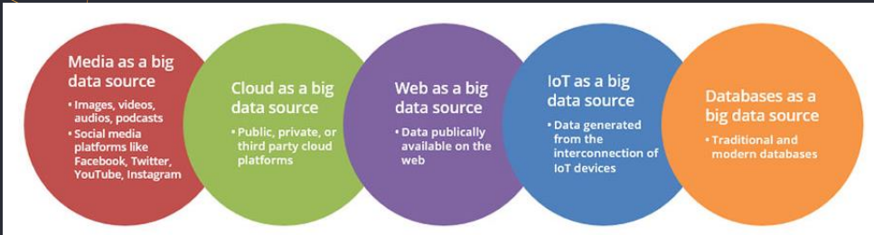

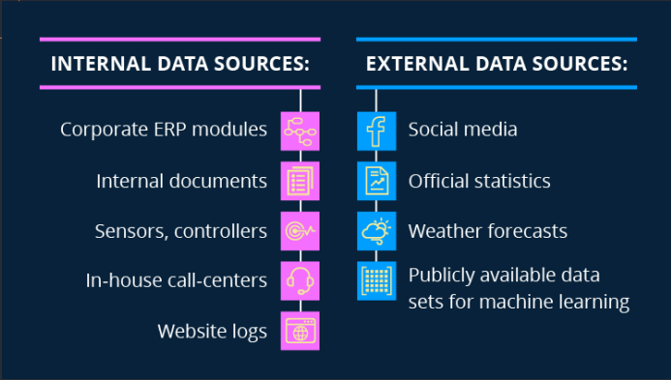

# **INTRODUCTION TO CLOUD COMPUTING**

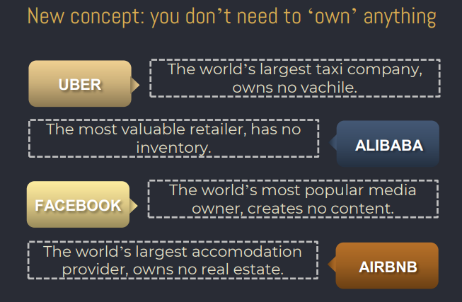

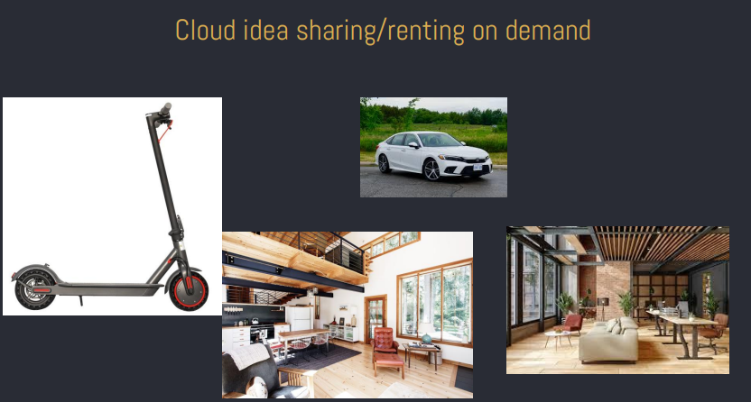

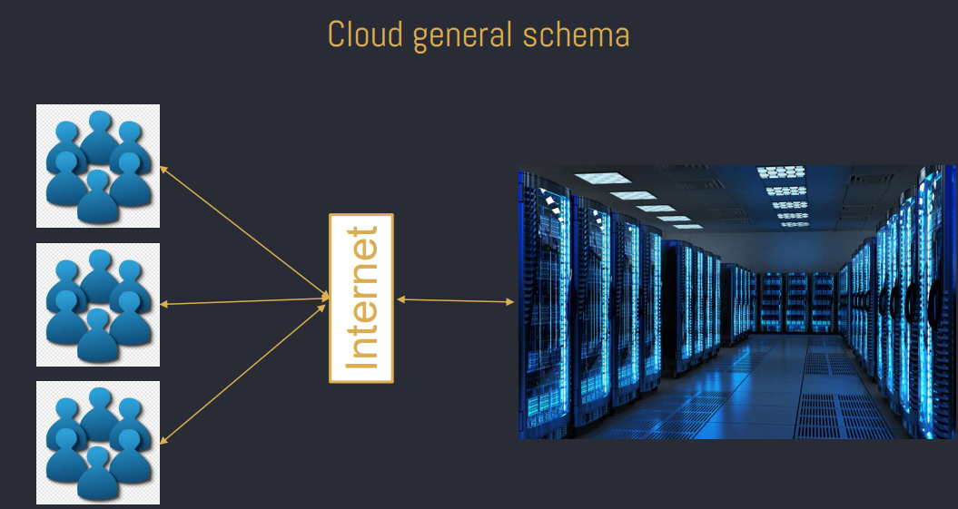

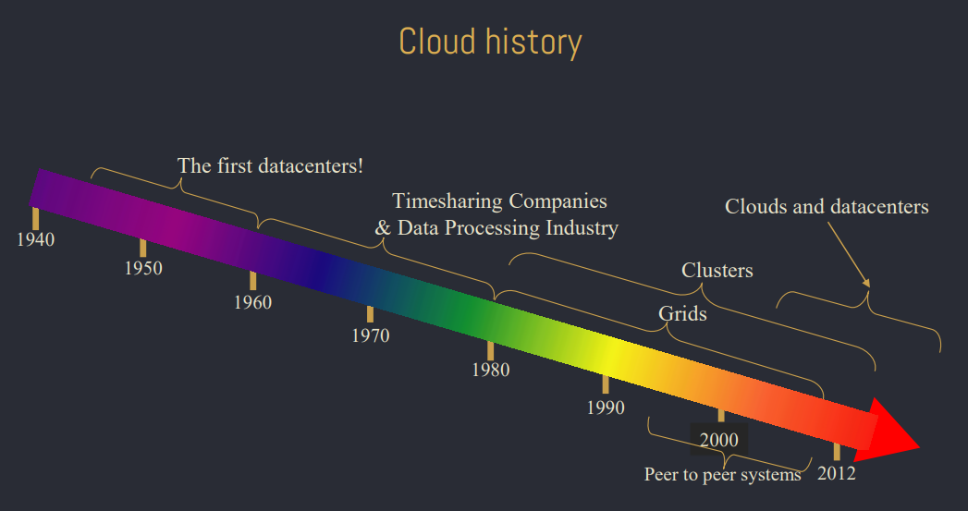

*Importance of Cloud Computing*

• Cloud spending to reach 50% across various markets by 2025, up from 41% in 2022.

• Application software spending via cloud computing is expected to increase to nearly two-thirds, up from 57.7% in 2022.

*Cloud actors*

• Cloud Client: Utilizes the resources of a cloud platform for various purposes. Examples include end users accessing cloud-based applications or companies utilizing cloud infrastructure for their operations.

• Cloud Provider: Manages and offers a hardware infrastructure and a range of services on top of it (Amazon Web Services, Microsoft Azure, etc.).

• Intermediate Cloud Provider: Acts as both a client of other cloud platforms and a provider for its own clients. These providers build and offer services using resources from other cloud platforms.

• Cloud Developer: Develops tools for the cloud environment, such as virtualization, deployment, and self-repair tools. These tools enhance the cloud's capabilities and support seamless operations.

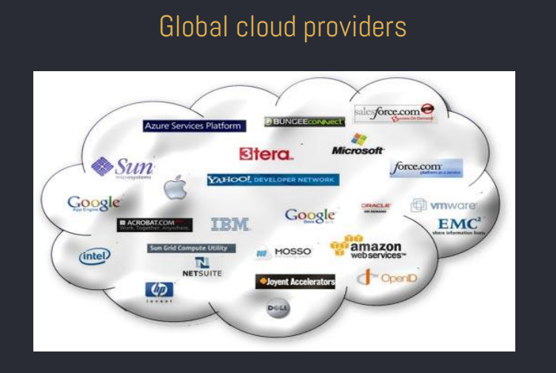

*Cloud Computing Use Cases*

• Data Storage and Backup: Store and back up large amounts of data securely.

• Software Development and Testing: Rapidly create and deploy applications in a scalable environment.

• Web and Mobile Applications: Host web and mobile applications in the cloud for global accessibility.

• Big Data Analytics: Process and analyze vast amounts of data using cloud resources.

• Disaster Recovery: Maintain data backups and recovery plans in the cloud for business continuity.

*The Big 3 Cloud Platforms*

*Amazon* - current market leader of the cloud computing platforms

• Prominent customers: Expedia, Netflix, Coinbase, Formula 1, Coca Cola, Airbnb.

*Microsoft Azure* - the second-largest cloud platform. Today, it is among the fastest-growing cloud platforms.

• Prominent customers: Daimler, HSBC, Starbucks, HP, Mitsubishi Electric.

*Google Cloud Platform* - currently offers over 100 services spanning computing, networking, big data, and more..

• Notable customers: Toyota, Spotify, Twitter (X), Paypal, UPS.

*Big 3 Cloud Platforms*

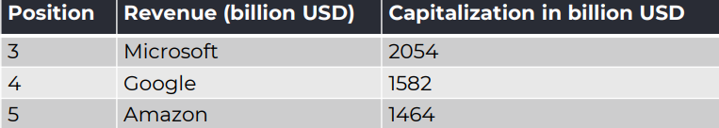

*Cloud key providers in the world - 2020*

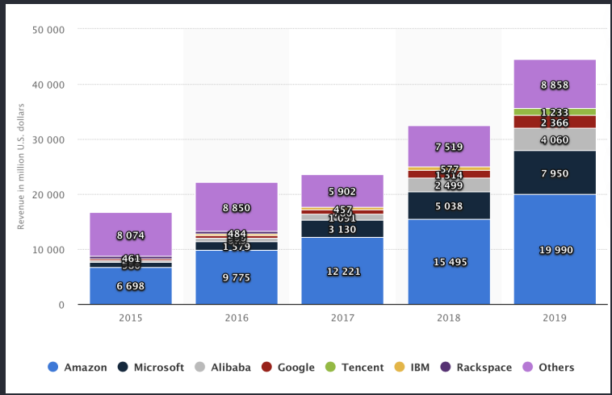

*History*

1955 - John McCarthy, the computer scientist who coined the term 'artificial intelligence,' is credited with envisioning time-sharing, proposing the concept of renting time-shared computing resources to companies unable to afford expensive computing technology.

1999 - Salesforce.com launched, marking the earnest beginning of cloud computing. Utilizing the matured Internet, Salesforce.com provided shared sales information, collaboration, storage, and reporting through a web-based portal, setting the stage for other companies to deliver applications and content over the Internet.

2002 - Amazon launched Amazon Web Services (AWS), a comprehensive cloud-based suite of resources encompassing storage, computation, and virtualization, effectively embodying the complete cloud computing definition.

*What is a cloud: word meaning*

• In the 1990s, telecommunications companies, previously focused on point-to-point data circuits, shifted to providing Virtual Private Network services that offered similar quality of service but at significantly reduced costs.

• By dynamically balancing traffic to optimize load distribution, these companies achieved more efficient utilization of their network bandwidth.

• The cloud symbol marked the boundary between the provider's responsibility (infrastructure) and the user's control. Cloud computing extended this boundary to include servers and network infrastructure. The term "cloud computing" was first used in a 1997 lecture by Ramnath Chellappa.

*What is a cloud: definition*

The National Institute of Standards and Technology

• defines cloud computing as a "pay-per-use model for enabling available, convenient and on-demand network access to a shared pool of configurable computing resources (e.g., networks, servers, storage, applications and services) that can be rapidly provisioned and released with minimal management effort or service provider interaction."

Basic

• A model of computation and data storage based on “pay as you go” access to “unlimited” remote data center capabilities

• A cloud infrastructure provides a framework to manage scalable, reliable, ondemand access to applications

• Cloud services provide the “ invisible ” backend to many of our mobile applications

*Opinions about Cloud*

Everything as a Service

• "Through the cloud, we can foster the information economy, address issues like the information explosion, globalization and environmental sustainability, and drive growth deep into the 21st century.” - Shane Robison, executive vice president, HP

• Cloud computing was simply a trap aimed at forcing more people to buy into locked, proprietary systems that would cost them more and more over time, Richard Stallman, founder of the Free Software Foundation and creator of the computer operating system GNU

## ***CLOUD COMPUTING CHARACTERISTICS AND IMPORTANCE***

*Critical characteristics*

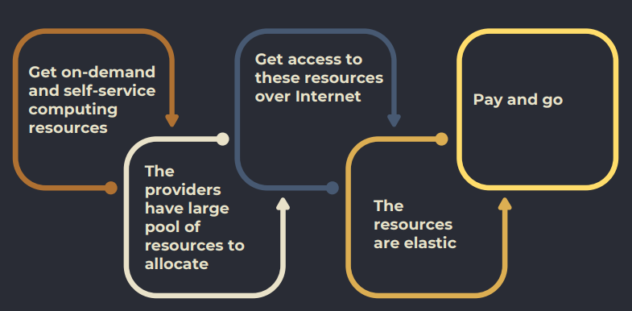

No need to purchase equipment, to hire technicians, to provide space, electricity, network facilities

*Cloud Computing: key characteristics*

On-Demand services Broad-access for all resources and services

* *Agility*: to allocate/deallocate resources quickly (in clouds usually it is seconds, instead of on-premises solutions)
* *Elasticity*: ability to scale dynamicaly the resources.
* *Scalability*: to add/remove resources vertical – size of the resource horizontal – amount of resources
* *Fault tolerance*: ability to run the applications during component or service failures human and natural causes
* *Self-managing services*: a consumer can provision cloud services as needed and automatically without requiring human interaction with each service’s provider
* *Accessible and highly available*: avail. =uptime/(uptime+downtime)

99% (3 days downtime), 99.9 (9 hours)

*Key facts: benefits*

* Agile development - Developer can use multiple virtual OSes to simulate and test cross-platform software.
* Save time - Deploy, setup, startup quickly
* Save money - Many companies require one app on one machine for reliability
* Save energy - Less physical servers, less energy consumption

*Cloud obstacles*

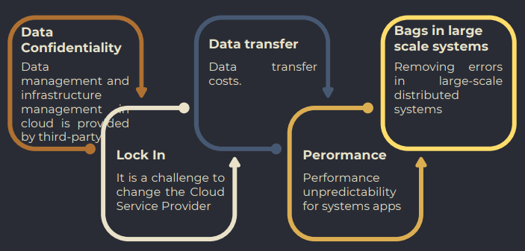

• In 2023, data centers are expected to consume approximately 3% of worldwide electricity.

• Security & Trust - Where are my data stored ? Are they protected ? Is privacy preserved ? What about the regulations in this country ?

*What is a cloud: topology*

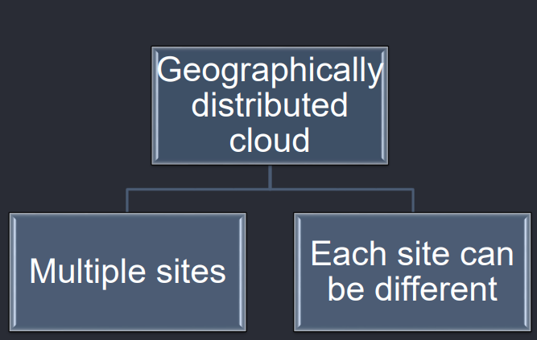

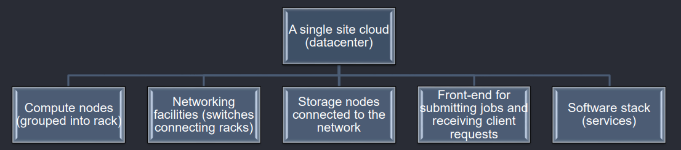

• Many servers belong to one rack

• A server may belong to multiple racks

• Many core switches talk one top of the rack switch

*Virtual networking in a Data Center*

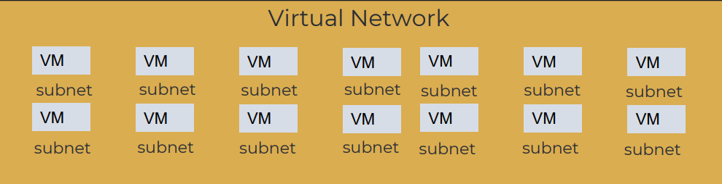

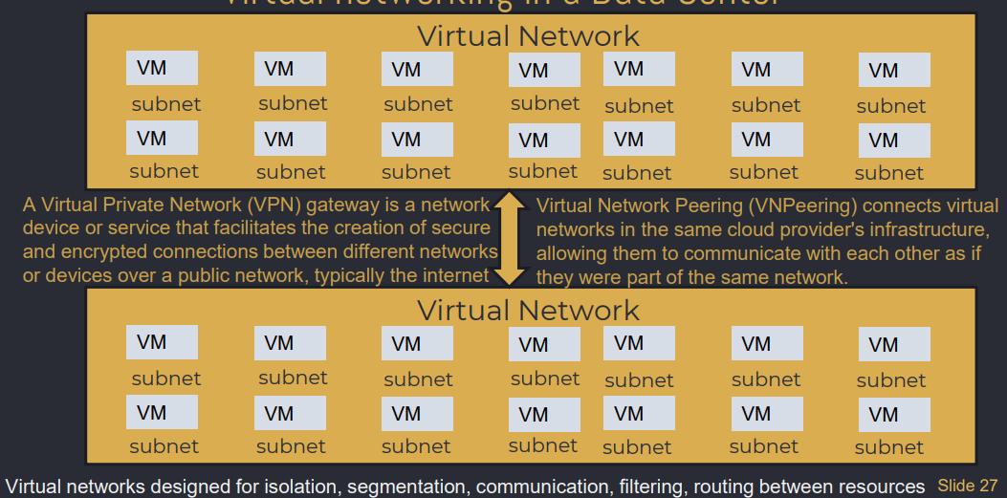

*Secure access*

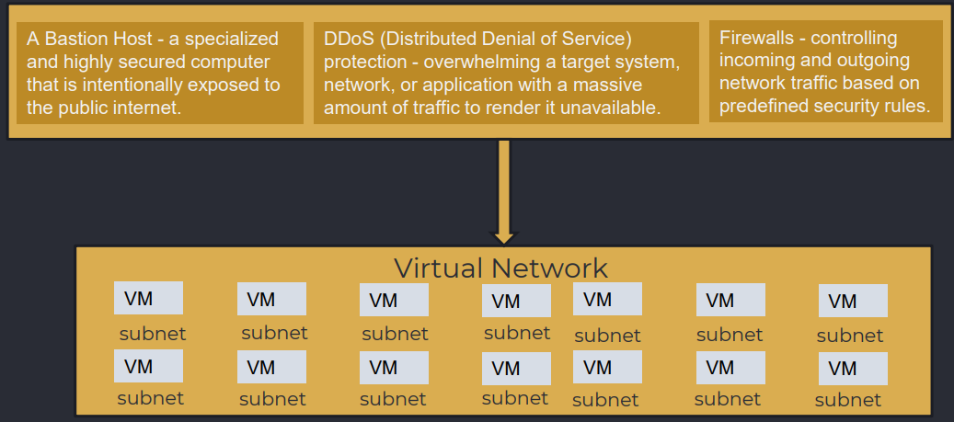

## *CLOUD DEPLOYMENT MODELS*

*Deployment Models – Private cloud*

• Infrastructure is dedicated to a single organization and may be located on-premises or off-premises.

• Private cloud environments are designed to meet specific security, compliance, or performance requirements.

• They offer enhanced control, customization, and privacy but require significant upfront investment.

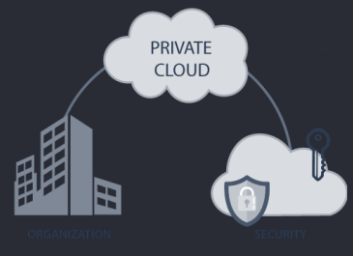

*Deployment Models - Public*

• Services are provided over a public network and available to anyone who wants to use them.

• It is a cost-effective option for businesses and individuals looking for scalability and flexibility.

• Public cloud providers, such as AWS, Azure, and GCP, offer a wide range of services accessible to the general public.

• We don’t have any own data center.

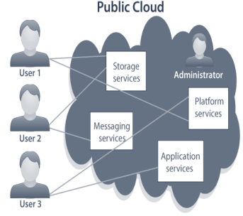

*Deployment Models - Hybrid*

• Combines public and private cloud environments, allowing for flexibility and data sharing between the two.

• Organizations can leverage the benefits of both public and private clouds, ensuring optimal resource allocation.

• Hybrid cloud deployments enable workload portability and seamless integration between different environments.

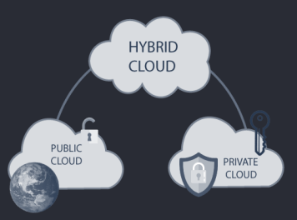

*Deployment Models – Community*

A community cloud shares the resources among a specific group of organizations with common interests, requirements, or compliance considerations.

• Government Agencies - Government organizations within a specific region or jurisdiction can collaborate and share resources in a community cloud.

• Healthcare - Healthcare providers and organizations can share electronic health records (EHRs) securely and efficiently.

• Education - Educational institutions can use a community cloud for collaborative research and data sharing.

*Deployment Models*

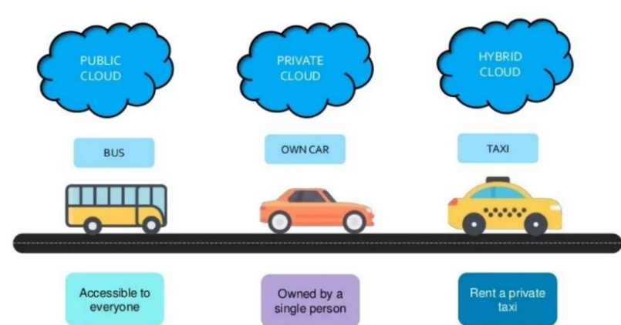

*Pros & Cons*

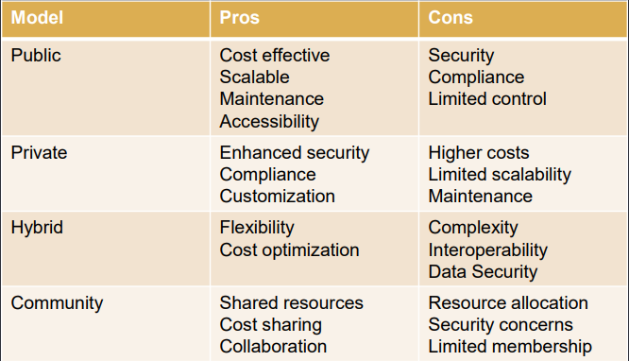

## *CLOUD SERVICE MODELS*

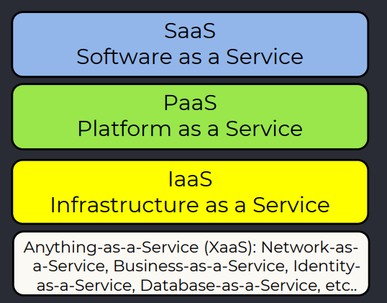

*Service models:* ***IaaS***

Provides basic storage and computing capabilities as standardized services over the network.

• Clients can connect to them and install and run any software

• Similar to dedicated servers (but here it’s virtual machines)

• The most popular type of cloud service Advantages

• Instant Scalability

• Security

• Reliability

• APIs

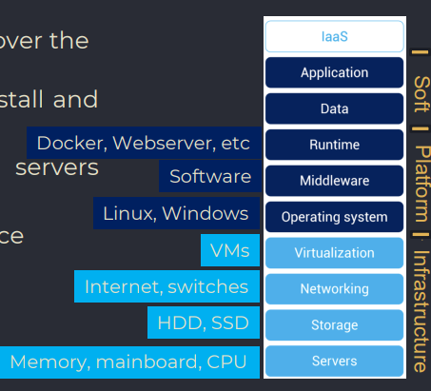

• Amazon Web Services (AWS) is a collection of remote computing services (also called web services) that together make up a cloud computing platform, offered over the Internet by Amazon.com.

• Microsoft Azure is Microsoft's public cloud platform.

• Google Cloud Platform (GCP) is a cloud computing platform and infrastructure for building, deploying, and managing applications and services on the web.

• Alibaba Cloud, also known as Aliyun, is the cloud computing of one of the largest e-commerce companies in the world.

*Service models:* ***PaaS***

PaaS provides all of the facilities required to support the complete life cycle of building and delivering web (or any other) applications and services entirely from the Internet (development frameworks, analytics and business intelligence).

Advantages

• Instant Scalability

• Security

• Reliability

• APIs

Popular Services

• Storage

• Databases

• Scalability

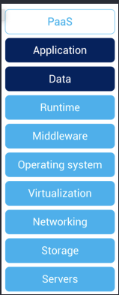

• Google App Engine

• Microsoft Azure

• Heroku

• Oracle Cloud Platform

• Red Hat OpenShift

• Pivotal Cloud Foundry

*Service models:* ***SaaS***

SaaS is a software delivery methodology that provides multi-tenant access to software and its functions remotely as a Web-based service.

SaaS advantages

• No hardware or software to manage

• Service delivered through a browser

• Instant Scalability

• Security

• Reliability

• APIs

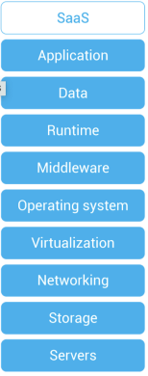

Google Apps: Gmail, Google Groups, Calendar, Talk, Docs

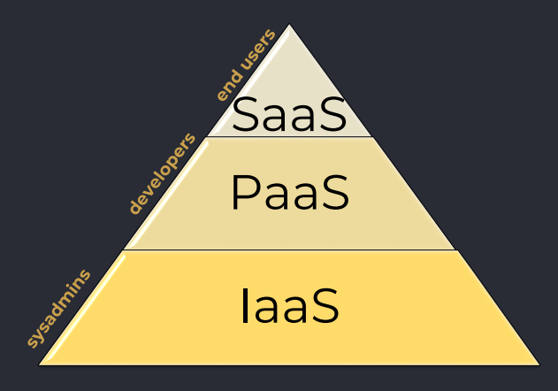

*Service models – Serverless Computing*

• Allows developers to concentrate on code by using external computational and data resources

• No infrastructure management needed

## *HOW CHOOSE CLOUD PROVIDER?*

*Data Center*

* own cooling
* power and
* network systems

*Region*

• Group of data centers connected to each other by high-throughput connectivity

• Cloud provider has several regions, which can be small and big consists of several and multiple data centers.

• For instance in USA, can be one in East US, one in West US

• Regions - Amazon (25), Microsoft Azure (>60), Google Cloud (27)

• Some services are available only in certain regions

• Special partner regions – like China Eat which is operated by the partner organization

Geo-locations allow to deploy applications to regional datacenters around the world.

*Availability Zones (AZs)*

• Within each region, provides redundancy and fault tolerance. They are located in separate facilities within a region to ensure that if one AZ experiences an outage, services can automatically failover to another AZ.

• Not all regions support AZs.

• Availability zones are primarily for virtual machines, managed disks, load balancers, and SQL databases.

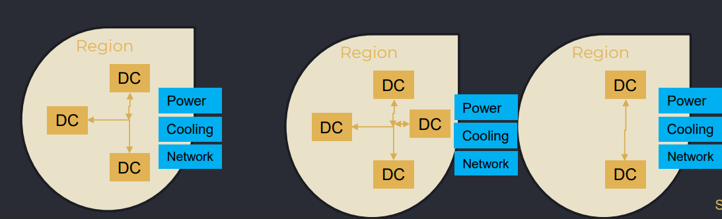

*Region pair*

Region Pairs are designed to provide data redundancy and failover capabilities. Data can be replicated from one Region to another in the pair for business continuity and disaster recovery purposes.

The idea behind Region Pairs is to ensure that data and applications are well-protected and available even in the face of regional disasters or outages.

Regon pairs are static and can’t be chosen (usually > 300 miles).

Examples of Region Pairs:

• A Region Pair is US East (N. Virginia) and US West (Oregon)

*How to choose a cloud service provider*

*Amazon Web Service* has 25 geographic regions with 81 availability zones. 218+ edge locations, and 12 Regional Edge Caches.

*Microsoft Azure* runs 60+ regions with a minimum of three availability zones in each region with more than 116 edge locations (Points of Presence).

*Google Cloud Platform* has 27 cloud regions with 82 zones and 146 edge locations.

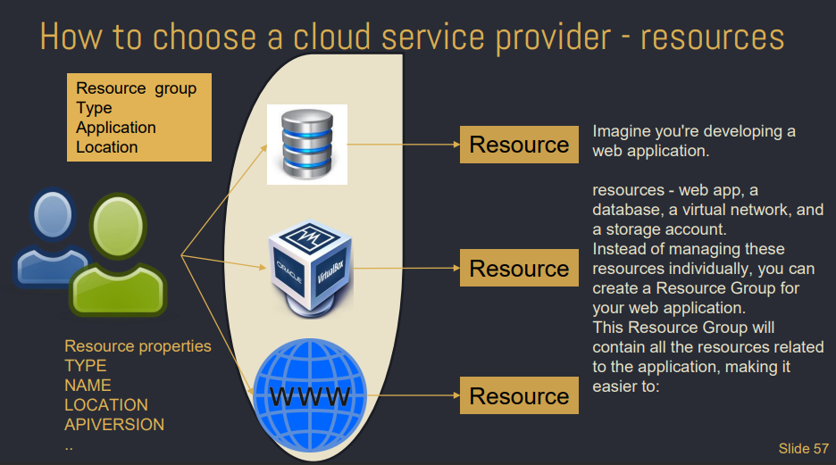

*Choose a cloud service provider – resource manager*

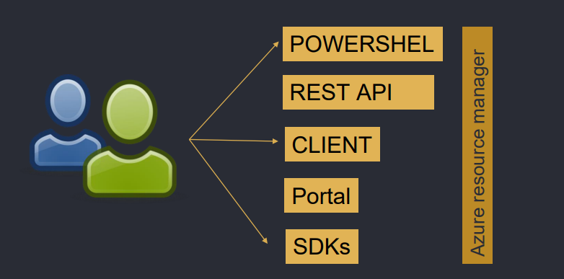

## *CLOUD SERVICES (CASE FOR MICROSOFT)*

*Compute*

• Virtual Machines (general-purpose, compute-optimized, memory-optimized)

• Virtual Machine Scale Sets (designed for high-scale applications, such as web applications or microservices, that need to automatically adjust the number of VM instances based on demand)

• Container instances

• Kubernetes services

• App services

• Functions

*Storage – Azure BLOB (BINARY LARGE OBJECT)*

• Azure Blob storage is an object storage solution that you can use to store massive amounts of unstructured data, such as documents, images, videos, and backups, in a scalable manner.

• Data Availability - high availability and redundancy options, ensuring your data is accessible even in the event of hardware failures.

• Tiered (Hot, Cool, Archive) - with varying costs and access times (hot very fast), allowing you to optimize storage costs based on data usage patterns.

• Data Encryption - Supports encryption at rest and in transit, keeping your data secure..

*Storage*

• File Storage (Microsoft Azure File Storage, Google – Google File Store, Amazon Elastic File System) – provide managed file storage solutions in the cloud, but they may have slightly different feature sets and performance characteristics. Azure Files offers fully managed file shares accessible via industry-standard SMB and NFS protocols.

• Table Storage (Microsoft Azure Table Storage, Google – Google Cloud Bigtable:, Amazon NoSQL Database) – semi-structured NoSQL data store that offers a scalable and schema-less storage solution for semi-structured data. It is used widely for user profiles, logs, configuration data, and sensor data.

*Database – Structured*

• Global cloud providers – SQL

• Supports various SQL database engines - MySQL, PostgreSQL, and SQL Server

• Choosing the right SQL database platform depends on factors - application's requirements, familiarity with the database engine, scalability needs, and the cloud platform you are already using or planning to adopt. Each of these services has its own unique features and capabilities that cater to different use cases and workloads.

*Database – Semistructured*

• Global cloud providers – Microsoft (Cosmos), Google (Filestore), Amazon (DynamoDB)

• Semi-structured globally distributed DB system.

• Multiple APIs – Sql, Cassandra, MongoDB, etc.

• Multi-Model - supports multiple data models, including document, key-value, graph, and column-family, making it versatile for various application scenario

• Serverless Compute - on-demand, pay-per-request pricing without the need to provision throughput.

*Big Data*

• Azure HDInsight - fully managed cloud service for Apache Hadoop, Spark, HBase, Kafka, Storm and other popular Big Data frameworks. It provides enterprise-grade security, scalability, and support for various analytics and machine learning workloads.

• Amazon EMR (Elastic MapReduce) - cloud-native big data platform for processing vast amounts of data using popular frameworks like Hadoop, Spark, Hive, and more. EMR provides scalability and cost-effectiveness for processing and analyzing large datasets.

*Storage tiers*

Storage tiers refer to different classes of storage that offer varying levels of performance, durability, and cost. Storage tiers allow you to optimize your storage costs based on the access patterns and priority of your data.

• Hot Access Tier: Ideal for frequently accessed data, such as recent or critical data.

• Cool Access Tier: Suitable for data that is accessed less frequently and stored for a longer duration.

• Archive Access Tier: Intended for long-term archival data with rare access.

• Premium Block Blob Storage: Geared towards high-performance, low-latency storage for block blobs.

*Redundancy options*

Redundancy options enhance the availability and reliability of data and services by maintaining multiple copies of data across different locations or systems. Redundancy helps ensure that data remains accessible even in the event of hardware failures, outages, or disasters.

• Locally Redundant Storage: redundancy within a single datacenter.

• Geo-Redundant Storage: redundancy across geographically distant datacenters within the same region.

• Read-Access Geo-Redundant Storage: allowing read access to the secondary region.

• Zone-Redundant Storage (ZRS): redundancy across multiple Availability Zones.

• Cross-Region Redundancy: redundancy across different regions.

• Content Delivery Networks (CDNs):Improves content delivery and reduces latency by distributing content to edge locations.

*ML*

• *Notebooks* - Jupyter notebooks for interactive data exploration and model development. You can use various programming languages, including Python and R.

• *Automated ML* - simplifies the process of model selection, hyperparameter tuning, and feature engineering. It allows data scientists and developers to build high-quality models with less manual effort.

• *Scalability* - to handle both small-scale and large-scale machine learning workloads, making it suitable for a wide range of projects.

*How to choose a cloud service provider*

Common services AWS and Azure have the largest service catalogs by offering more than 200+ services. GCP currently offers around 100+ services.

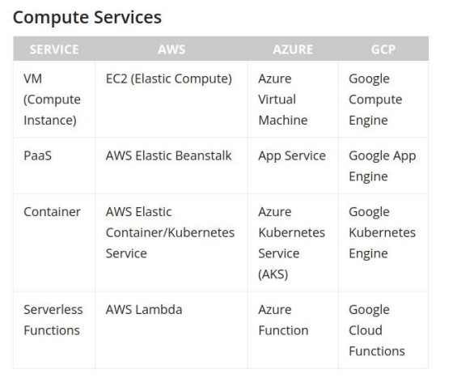

Common services

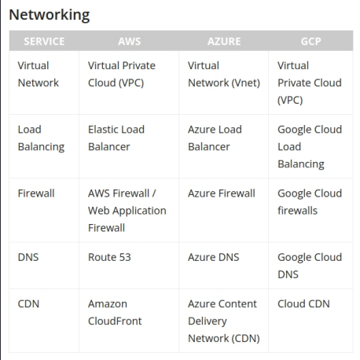

Pricing - depends on many factors:

• Customer requirements

• Usage

• The services used

All three platforms offer competitive pricing plans with additional cost management options—reserved instances, budgets, and resource optimization—available to all users.

The consensus in the IT community is that Microsoft Azure has the lowest ondemand pricing while Amazon tends to come somewhere around the middle. However, there is a clear advantage when enterprise customers already using Microsoft services (Windows, active directory, MS SQL, etc.) move to Azure as it is significantly cheaper than other cloud providers.

## *CLOUD SECURITY AND PRIVACY*

*Mechanisms*

• Protect your privileged credentials with multifactor authentication

• Stay up to date on all operating system and application patches

• Restrict public access to only what’s required

*Pillar 1: Data protection*

Data protection is all about data in transit and data at rest encryptions.

• Data in transit - Transport Layer Security (TLS) and IPsec cloud security protocols protect your data as it moves from one place to another, whether within the cloud or traveling between an on-premise data center and cloud resources.

• Encryption at rest - protects the data held within buckets, databases, or data lakes within a cloud provider. All the cloud providers support the industry standard AES 256-bit encryption. This type of encryption means an attacker cannot access or read your data without an encryption key.

*Pillar 2: Infrastructure protection*

The infrastructure protection controls access to the networks. Cloud providers offer several tools like

• Web Application Files service

• DDoS protection service

*Pillar 3&4: Detection controls and incident response*

• Detection controls identify organizational or application security flaws so you can act on them. The goal is to identify threats, weaknesses, vulnerabilities, and incidents. All the cloud providers offer native tooling to actively scan for vulnerabilities, misconfigurations, suspicious activities, and compromised instances.

• Incident response aims to automate as much as possible. Each cloud provider has serverless functions that can, for example, programmatically remediate common scenarios like a compromised EC2 instance. With serverless technology and an event-driven architecture, you could isolate it from the network and notify the appropriate team.

*Pillar 5: Identity and access management*

• Identity and access management (IAM) ensures that all users and components can access cloud resources only as intended.

• Use the least privilege to give developers access only to the services they need to deploy their applications.

• Role-based access controls mapped to job functions help define access to cloud resources.

• Logging lets you monitor it all to ensure your IAM policies are being enforced.

*Regulatory protocols (GDPR)*

General Data Protection Regulation (GDPR) applies to the protection of personal data of individuals within the EU and the European Economic Area.

• Individuals have more control over their data, including the right to access, correct, and delete personal information.

• Penalties: Non-compliance can lead to substantial fines, up to 4% of the organization's global annual turnover or €20 million, whichever is higher.

*Regulatory protocols (HIPAA, PCI DSS)*

• Health Insurance Portability and Accountability Act (HIPAA) applies to healthcare providers, health plans, and healthcare clearinghouses that handle protected health information.Penalties: Civil and criminal penalties for HIPAA violations can range from $100 to $50,000 per violation.

• Payment Card Industry Data Security Standard (PCI DSS) applies to all organizations that process, store, or transmit payment card data. Penalties: Non-compliance can result in fines, loss of payment card processing privileges, and increased liability in the event of a data breach.

## *COST MANAGEMENT*

*Company scalling*

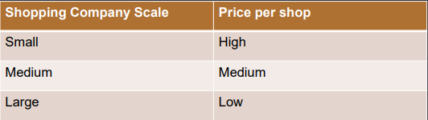

*CapEx vs OpEx*

Capital Expenditure (own infrastructure)

• Initial investment (Equipment, network, power, etc.)

• Maintenance (support staff, hardware failures, etc.)

Operational Expenditure

• Rent infrastructure

• No initial investment

• No maintenance by user

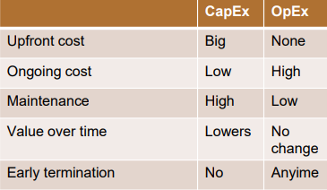

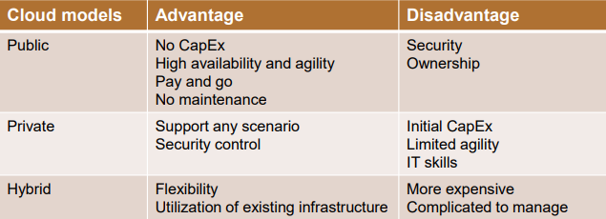

SaaS (usually, one version of the application is used for all customers) - licensed through a monthly or annual subscription. PaaS and IaaS - consumption-based model, so you only pay for what you use.

*Cloud costs*

• Compute - compute instance types, each offering a certain amount of CPU resources, memory, and in some cases, specialized hardware such as fast networking or graphics acceleration.

• Storage - customers pay by GB-month of storage utilized for elastic storage services. For managed storage services, customers pay for an entire storage volume.

• Networking - Bill customers according to the volume of data transferred into the cloud service (ingress), out of the cloud service (egress), or both.

The Azure Pricing calculator allows you to estimate and configure according to your specific requirements. You will then receive a consolidated estimated price and a detailed breakdown of the costs associated with each resource you added to your solution.

*Pay-as-you-go model*

Pay-as-you-go cloud computing (PAYG cloud computing) payment method charges based on usage.

• The practice is similar to that of utility bills, using only resources that are needed.

• One significant benefit of the pay-as-you-go model, a form of consumption-based pricing, is that there are no wasted resources. Users only pay for what they use rather than a certain amount of resources that may or may not be used

*Prepaid/fixed model*

• Cloud customers pay for services upfront.

• Subscription prices deliver a predetermined package of services for a specified time.

• The longer the period, the lower the price. Most cloud providers also offer subscription-based pricing for customers with high spending, allowing them to enter into a corporate discount plan, where they commit to a certain level of cloud spend and receive a discount on some or all of their cloud services.

*Spot model*

• Spot instances are usually the lowest-cost computing option, offering discounts of up to 90% compared to pay-as-you-go rates.

• The lower cost comes with the provision that these Azure spot instances can be taken away with minimal warning if demand for capacity increases or instances are needed to service reserved instances or pay-as-you-go customers.

• Ordinarily, spot instances can only be used for stateless, faulttolerant workloads or processes that can be stopped and restarted.

*Service level agreement (SLA)*

SLA is a contractual agreement between a cloud service provider and its customers that outlines each party's performance metrics, service availability, and responsibilities. Here are some key points to understand about cloud SLAs:

• Performance metrics - such as uptime, response time, or latency.

• Service availability - guaranteed availability of the cloud services during specific timeframes (99.99%).

• Downtime and outages - procedures for reporting and resolving downtime or outages.

• Data security and privacy - ensuring the provider takes appropriate measures to safeguard customer data.

• Customer support and response time.

## *CLOUD MANAGEMENT*

*Cloud management software*

• OpenStack (initiated by NASA and Rackspace) is an open-source cloud computing platform that provides scalable and flexible infrastructure for managing public and private clouds.

• CloudStack offers a robust set of features, including virtual machine management, networking, storage, and user access controls, making it a comprehensive solution for cloud infrastructure management. CloudStack supports both the Amazon Web Services (AWS) API and the Open Cloud Computing Interface (OCCI). This means that users can interact with CloudStack using AWS API-compatible tools and applications, as well as with OCCI-compliant clients, allowing for interoperability and flexibility in managing cloud resources.

• OpenNebula provides a simple and flexible way to create and manage virtual machines, storage, and networking resources. The platform offers features such as self-service provisioning, automatic resource allocation, and monitoring, enabling efficient utilization of cloud resources. OpenNebula also supports hybrid cloud deployments, allowing users to seamlessly integrate resources from public cloud providers like Amazon Web Services and Microsoft Azure with their private cloud infrastructure.

• Proxmox Virtual Environment (Proxmox VE) allows users to deploy and manage virtual machines and containers in a single integrated solution.

*Why Openstack*

• Powerful open-source environment that grants complete control over cloud computation. This flexibility has led numerous corporations to adopt their tailored versions of OpenStack.

• Scalability simplifies server administration tasks, allowing seamless expansion as needed. The platform's robust API, continuously improved by global developers, ensures excellent community support.

• Major IT players like Huawei, Intel, and Red Hat have embraced OpenStack for their cloud management needs, further attesting to its prominence and reliability.

*Openstack components*

• Nova - computing engine which manages a large number of VMs and other instances, which handle computing tasks.

• Swift - storage system to store objects and files. Instead of referring to the file and objects through the path, developers can instead refer to them through a unique identifier, which points to a file or piece of information and thereby allow OpenStack to manage where to store the files. This reduces the effort of the developers to understand and worry about storage distribution.

• Cinder - block storage component of OpenStack. This functions in a way, analogous to the traditional ways of locating and accessing specific locations on a disk or a drive.

• Neutron - enables networking.

• Horizon - dashboard that provides all the possibilities for the system administrators to access and manage the cloud.

• Keystone - provides identity services for all users.

• Glance - image services in OpenStack, where images refer to the virtual copies of the hard disks.

• Ceilometer - performs a close regulation of each user's cloud components' usage and provides a bill for the services used.

• Heat - allows developers to store the requirements of a cloud application in a file so that all the resources necessary for a program are available at hand.

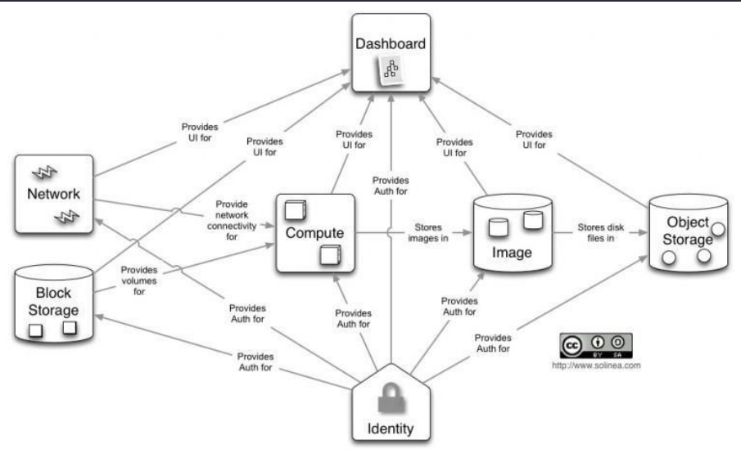

# **APACHE HADOOP**

*Distributed Computing*

● Consists of several interconnected nodes. Nodes can be physical and virtual machines or containers.

● When a group of nodes provides services and applications to the client as if a single machine, it is also called a cluster.

*Hadoop*

● A framework for running jobs on clusters of computers that provides a good abstraction of the underlying hardware and software.

● An open-source project of the Apache Software Foundation (founded in 1999 and is based in the United States), which provides a collaborative environment for developing open-source software projects (Apache HTTP Server, Apache Tomcat, Apache Hadoop, Apache Spark, Apache Cassandra, or Apache Kafka).

● Java is used for its core components

● Initially released in 2006. The last stable version is 3.3.1 from June 2021

● Originally inspired by Google‘s MapReduce and is a Google File System continuation

*Hadoop benefits*

● Highly scalable

● Fault tolerance

● Data locality

● High availability

● Processing speed

● Cost-effectiveness - not need high-end hardware

● Easy to learn

● Data can be queried through SQL-like endpoints (Hive, Cassandra)

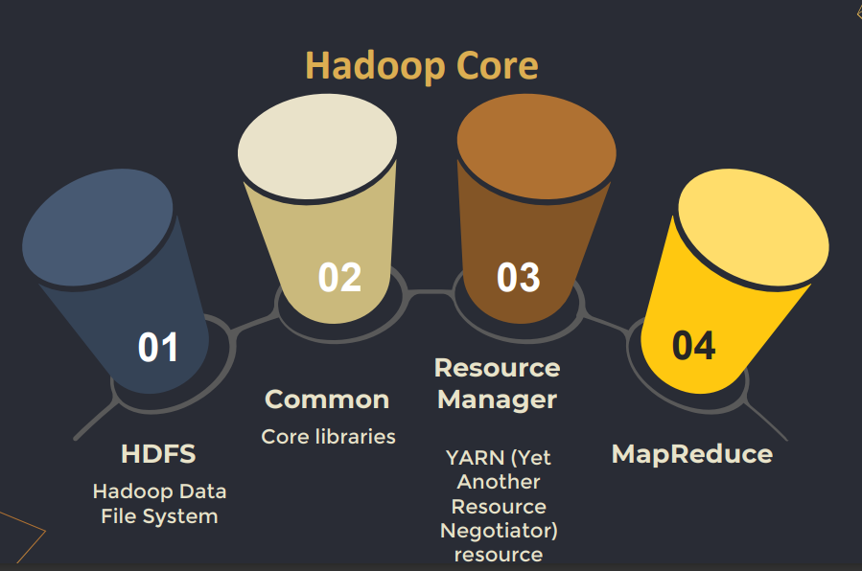

# **HDFS – HADOOP DISTRIBUTED FILE SYSTEM**

● Java-based file system that provides scalable, fault tolerance, reliable and cost-efficient data storage of Hadoop for storing large datasets across clusters of machines.

● There are two major components of HDFS - NameNode (Master) and DataNode (Slave).

*HDFS – fault tolerance*

● Replication (creating multiple copies /usually 3/ of the data) - to prevent data loss and/or task termination due to hardware failures.

● Erasure coding - the data is broken into fragments, encoded, and stored anywhere. Erasure coding also uses less storage capacity than RAID, allowing data recovery if two or more parts of a storage system fail. Erasure coding can provide the same level of fault tolerance as replication but with lower storage overhead.

*NameNode (Master)*

The NameNode is responsible for the bookkeeping of the data partitioned across the DataNodes, manages the whole filesystem metadata, and performs load balancing, which means that the NameNode stores metadata i.e. number of blocks, their location, on which Rack, which Datanode the data is stored and other details. It consists of files and directories.

*HDFS Secondary NameNode*

An additional standby node is needed to guarantee high availability (since the NameNode is a single point of failure).

*DataNode (sometimes called computational nodes)*

● Responsible for storing actual data in HDFS.

● Performs read and write operations as per the request of the clients.

Tasks

● DataNode performs operations like block replica creation, deletion, and replication according to the instruction of NameNode.

● DataNode manages the data storage of the system.

*HDFS Internal Data Representation*

● HDFS splits data into blocks for internal storage. One reason for doing so is to ensure that all block objects have the same size.

● The block size can be configured during installation.

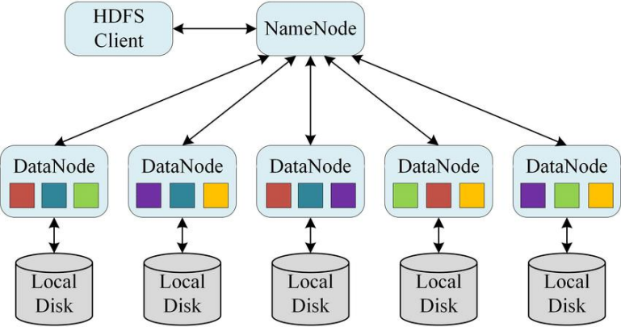

*HDFS DataNode Failure*

● Regularly, each DataNode send heartbeat messages to the NameNode to indicate that they are alive and functioning properly.

● If the DataNode becomes unavailable, the NameNode stops sending requests to that node and creates new replicas of the blocks stored on that node.

*HDFS WORM Principle WORM - Write Once Read Many*

When the WORM feature is enabled, files are treated as "readonly". Once a file has been written, it cannot be modified, renamed, or deleted. Only users with special permissions can modify or remove the file from the cluster.

*Common HDFS File Commands*

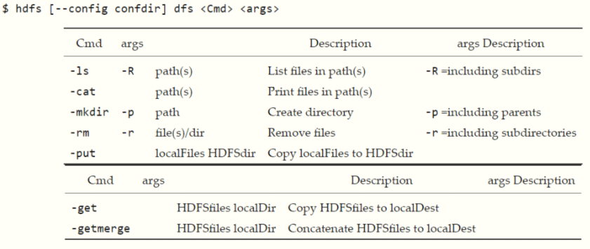

*HDFS Basic Commands*

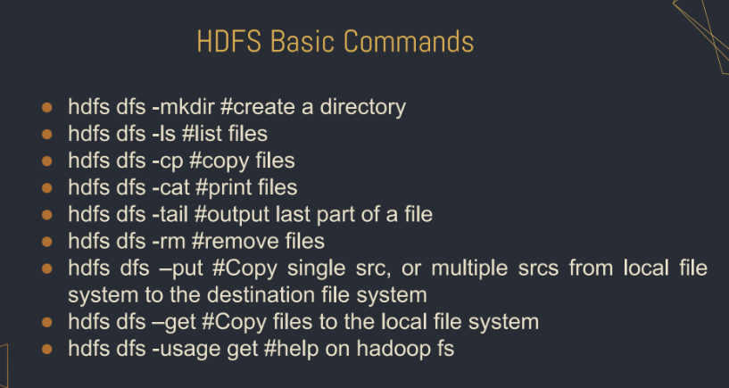

*Generate file with specific size*

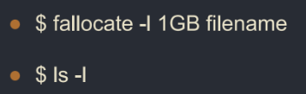

*HDFS Commands to try*

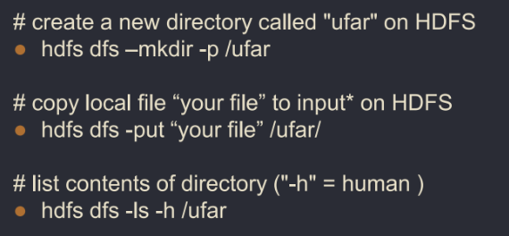

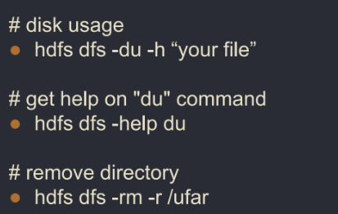

*HDFS Commands – disk usage*

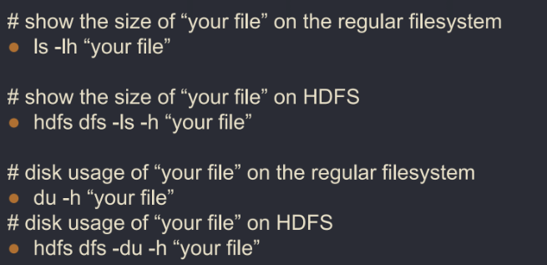

# **MapReduce Hadoop**

MapReduce is a programming model that simultaneously processes and analyze large-scale datasets logically into clusters.

It was developed by Google to handle large-scale data processing tasks, and has since become a widely used tool in data analytics and big data processing.

*Why use MapReduce in general?*

Allows for efficient processing of large datasets that would be difficult or impossible to process on a single machine.

It breaks down a large dataset into smaller chunks that can be processed in parallel across multiple machines, which can significantly reduce the processing time for large-scale data analysis tasks.

*Why use MapReduce - fault tolerance, scalability?*

Provides fault tolerance, meaning that if one machine fails or encounters an error during processing, the job can be automatically rerouted to another machine without losing any data or progress.

MapReduce is its scalability. As the size of the dataset grows, more machines can be added to the processing cluster to handle the increased workload.

MapReduce algorithm (introduced by Google in 2004) makes it easy to distribute a job and run it in parallel in a cluster, which consists of two phases:

1. Map phase - takes a set of data and converts it into another set of data, where individual elements are broken down into tuples (key/value pairs),

2. Reduce phase - takes the output from the Map as an input and combines those data tuples based on the key and accordingly modifies the value of the key.

*MapReduce Steps*

Step 1 (Split)

Data is partitioned across several computer nodes.

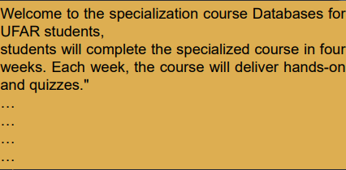

Step 2 (Map)

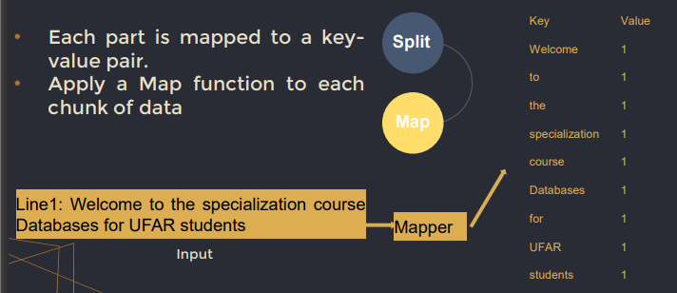

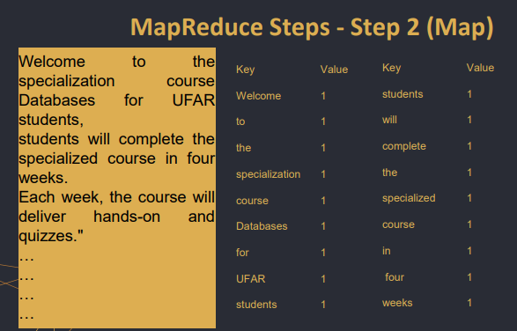

Step 3 (Sort/Shuffle)

● Often the most costly in a MapReduce job as the mapping outputs must be merged and sorted to transfer them to the reducer(s).

● The purpose of sorting is to provide data that is already grouped by key to the reducer. This way reducers can iterate over all values from each group.

● Groups together all key-value pairs that have the same key, so that they can be processed by the same reducer

The choice of sorting algorithm depends on the size of the dataset and the available resources. In some cases, an external sorting algorithm may be used if the dataset is too large to fit into memory.

● Quicksort - divide-and-conquer sorting algorithm that works by partitioning an array into two sub-arrays, one containing elements smaller than a pivot element, and the other containing elements greater than the pivot element. The pivot element is chosen randomly from the array.

● Mergesort - divide-and-conquer sorting algorithm that works by dividing an array into two halves, recursively sorting each half, and then merging the sorted halves back together.

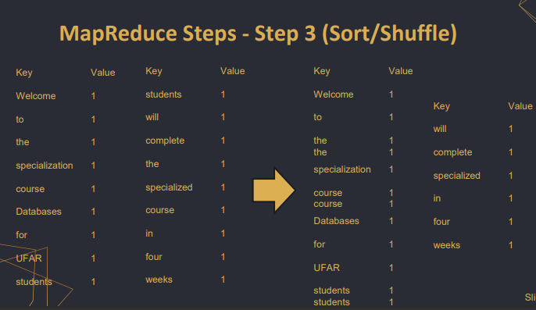

During the Shuffle step, the MapReduce framework divides the sorted key-value pairs into partitions based on the number of reducer nodes in the cluster. Each partition contains all the key-value pairs with the same key range, which will be processed by a single reducer. The partitions are then sent to the reducer nodes.

● If you have five reducers, the shuffle phase in MapReduce will distribute the intermediate key-value pairs emitted by the map phase into five partitions based on a partitioning function. The partitioning function maps each intermediate key to one of the five reducers, and all key-value pairs with the same key will be sent to the same reducer.

The reduce function is applied to the data and an output is produced

● Count - number of values for each key

● Sum - sum of values for each key

● Max and min

● ..

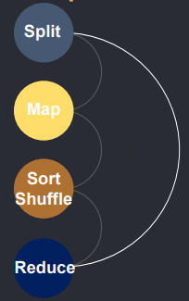

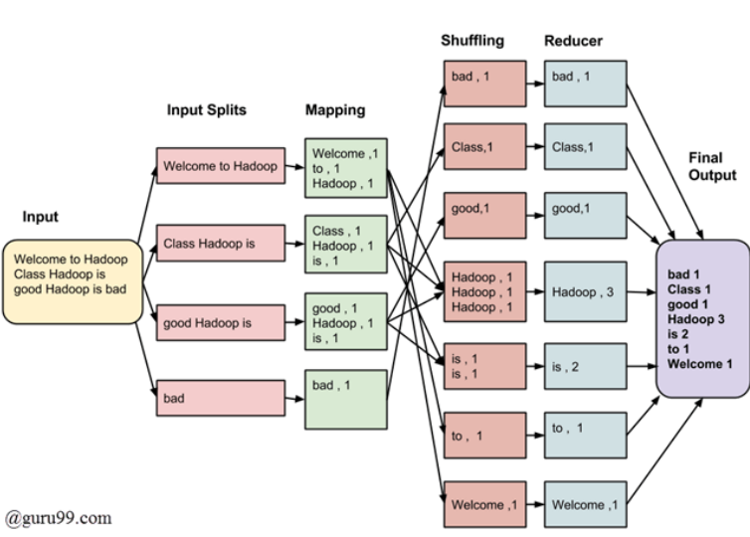

*Example*

mapper.py

*#!/usr/bin/env python  
  
import* sys  
  
*# reading entire line from STDIN (standard input)  
for* line *in* sys.stdin:  
 *# to remove leading and trailing whitespace* line = line.strip()  
 *# split the line into words* words = line.split()  
  
 *# we are looping over the words array and printing the word  
 # with the count of 1 to the STDOUT  
 for* word *in* words:  
 *# write the results to STDOUT (standard output);  
 # what we output here will be the input for the  
 # Reduce step, i.e. the input for reducer.py  
 print*('%s\t%s' % (word, 1))

reducer.py

*#!/usr/bin/env python  
  
import* sys  
  
current_word = *None*current_count = 0  
word = *None  
  
# read the entire line from STDIN  
for* line *in* sys.stdin:  
 *# remove leading and trailing whitespace* line = line.strip()  
 *# splitting the data on the basis of tab we have provided in mapper.py* word, count = line.split('\t', 1)  
 *# convert count (currently a string) to int  
 try*:  
 count = *int*(count)  
 *except ValueError*:  
 *# count was not a number, so silently  
 # ignore/discard this line  
 continue*

*# this IF-switch only works because Hadoop sorts map output  
 # by key (here: word) before it is passed to the reducer  
 if* current_word == word:  
 current_count += count  
 *else*:  
 *if* current_word:  
 *# write result to STDOUT  
 print*('%s\t%s' % (current_word, current_count))  
 current_count = count  
 current_word = word  
  
 *# do not forget to output the last word if needed!  
if* current_word == word:  
 *print*('%s\t%s' % (current_word, current_count))

# **YARN**

*Yet Another Resource Negotiator*

● It is called as the OS of Hadoop as it is responsible for managing and monitoring workloads.

● It allows multiple data processing engines such as real-time streaming and batch processing to handle data stored on a single platform.

*YARN components*

Resource Manager - has the privilege of allocating resources (memory, CPU/vCores) for the applications in a system, consists of the Scheduler and application manager

● Scheduler - allocates resources across all applications

● Applications Manager - accepts job submissions, restart Application Masters on failure

● Nodes Manager - works on the allocation of resources such as CPU, memory, bandwidth per machine and later on acknowledges the resource manager

● An Application Master is the local application manager, responsible for negotiating resources, monitoring status of the job, restarting failed tasks

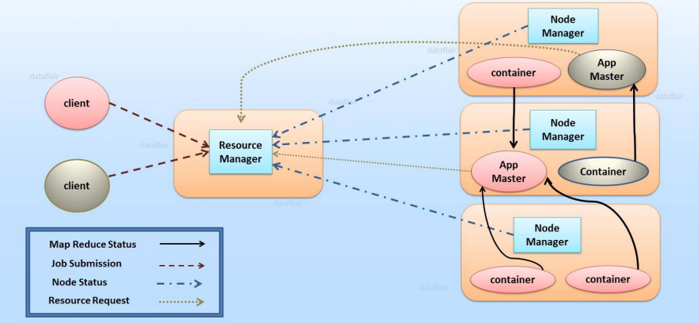

*Features of YARN*

● Flexibility – Enables other purpose-built data processing models beyond MapReduce (batch), such as interactive and streaming.

● Efficiency – As many applications run on the same cluster, Hence, efficiency of Hadoop increases without much effect on quality of service.

● Shared – Provides a stable, reliable, secure foundation and shared operational services across multiple workloads.